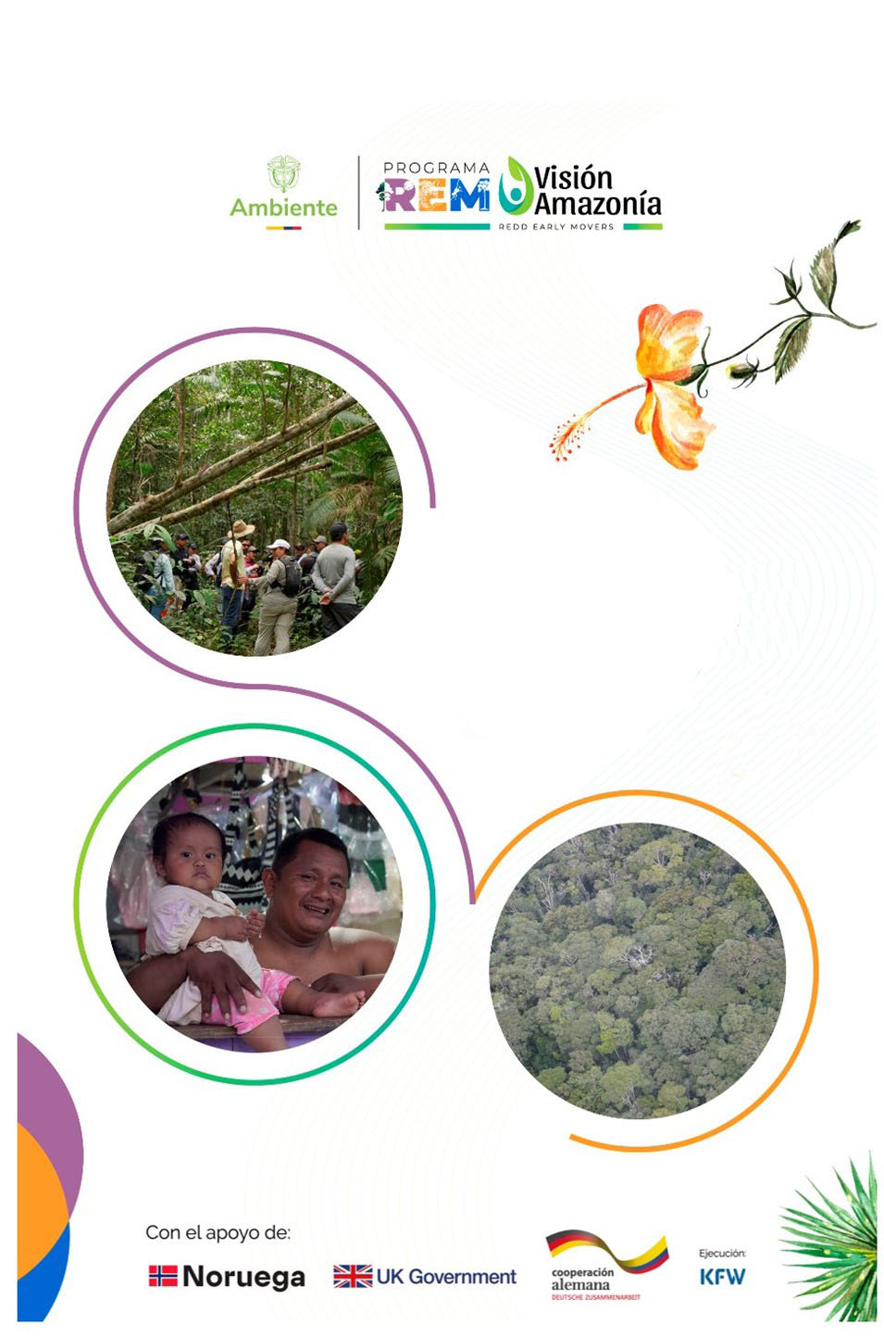
REM Colombia II
Visión Amazonía Programme
ANNUAL
REPORT
2024
REM Colombia II Visión Amazonía Programme
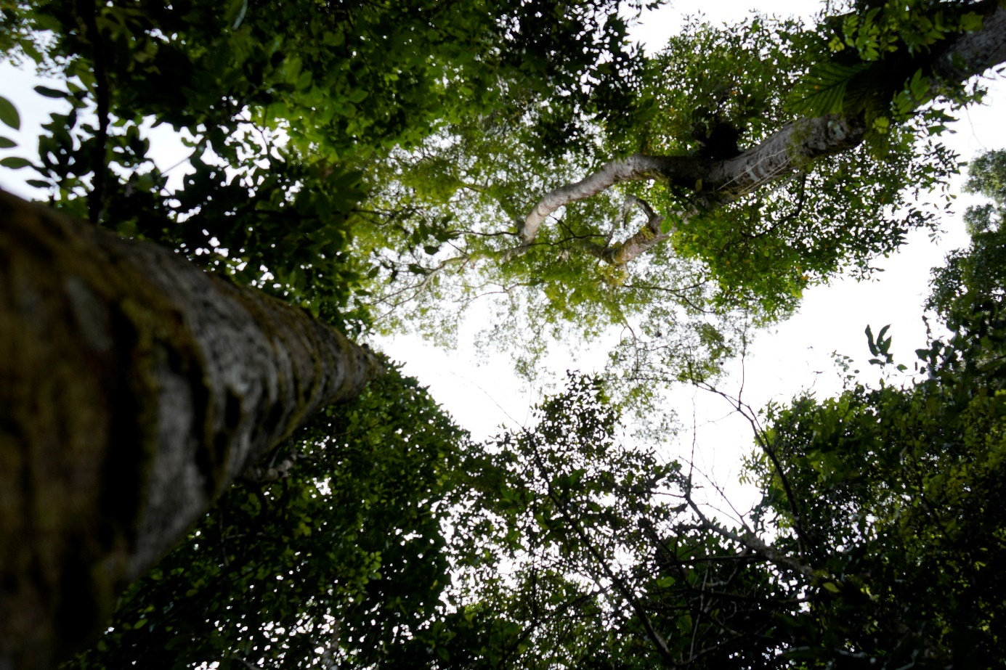
Photograph: Wilmer Alexander Mogollón
ANNUAL REPORT
January - December 2024
With the support of:
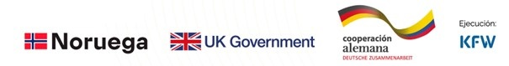
Contents
Summary of the REM Colombia II Visión Amazonía Programme ………………………...7
Executive Summary ……………………………………………………………………….8
Deforestation 2023 and 2024 8
Programme management progress 8
Executing Unit of the REM Programme [UER} 12
Communications 12
Management of social and environmental safeguards 13
Budget execution 13
Progress on Logical Framework Indicators 14
1 Introduction 15
1.1 Deforestation behavior in 2023 and 2024 16
2 Status of Implementation of the REM Colombia II Visión Amazonía Programme 20
2.1 Result 1 Forest Development Units [NDF] are implemented within the framework of an integrated strategy for territorial intervention. 20
2.1.1 Forest and Biodiversity based Development Units [NDFyB] Los Puertos 22
2.1.2 NDFyB Agua Bonita 28
2.1.3 NDFyB Orotuyo 33
2.1.4 NDFyB New Illusion 36
2.1.5 NDFyB Ciudad Yari 40
2.1.6 NDFyB Camuya 44
2.1.7 Complementary investments outside of the NDF 46
Amazon Forest Incentive [IFA] 46
2.2 Result 2 Indigenous peoples and communities are strengthened in their environmental governance. 50
2.3 Result 3 Territorial entities and national and regional environmental authorities strengthened in forest management and governance and in monitoring deforestation. .…………………………………………………………………………………..55
2.4 Communications Strategy 58
2.5 Questions, Complaints and Claims Mechanism Prior Consultation of the Visión Amazonía Programme 59
2.6 REM Executing Unit [UER] 60
2.6.1 UER Team 60
2.6.2 Programme coordination spaces 61
2.6.3 Synergies with other Cooperations 62
2.7 Programme Risk Management and Safeguards 63
2.6 Progress with Logical Framework Indicators 65
3 Budgetary Management of the Colombia II Visión Amazonía Programme 69
3.1 Budgetary Execution of Investment Plans 70
3.2 Budget execution by Pillars 71
3.3 Budget execution by Results 73
3.4 Financial yields and exchange rate differential 73
3.5 Benefit Distribution, Stock and Flow 74
4 Changes in the implementation context 75
5 Challenges and priorities for REM II 75
6 Annexes………………………………………………………………………………….77
Annex 1 Definitions of financial concepts 77
Annex 3: National Organization of Indigenous Peoples of the Colombian Amazon [OPIAC] proposal presented at the Regional Amazonian Roundtable [MRA], to redefine the pillars of the Visión Amazonía Programme to incorporate indigenous peoples. 85
Annex 4: Some links to news articles about the Programme published in the media. 86
Annex 5 Budget Execution by Pillars and Components (€) 87
Annex 5 Budget Execution by Implementing Entities (€) 88

Index of Tables
Table 1 Dynamics of forest loss in municipalities of interest. Period 2022-2023. 17
Table 2 Consolidated estimated deforestation in the Amazon, based on early warning reports January - September 2024. 18
Table 3 Deforestation reduction trend in NDFyBs 19
Table 4 Hectares under sustainable forest management and families involved in Forest and Biodiversity based Development Units [NDFyB] 21
Table 5 Investment progress NDFyB Los Puertos (in € ) 27
Table 6 Investment progress in the Agua Bonita NDFyB (in € ) 33
Table 7 Investment progress in NDFyB Orotuyo (in € ) 36
Table 8 Investment progress in NDFyB Nueva Ilusión (in € ) 39
Table 9 Investment progress in NDFyB Ciudad Yarí (in € ) 44
Table 10 Investment progress in NDFyB El Camuya (in € ) 45
Table 11 Closure of the Amazon Forest Incentive [IFA] operation 48
Table 12 Conservar Paga (Conservation Pays)Families 50
Table 13 Activities developed in Control and Surveillance in the year 2024 55
Table 14 National Land Agency [ANT beneficiary parcels within the NDFyBs 57
Table 15 Followers by social network 59
Table 16 Progress of Logical Framework Indicators 65
Table 17 Contribution of the Programme to the macro-targets of the National Development Plan 2022 - 2026 68
Table 18 Investment Plans approved in REM II 69
Table 19 Budget Execution of Investment Plans BY Disbursement [PID] and Investment Returns-based Investment Plan [PIR] 70
Table 20 Main appropriate processes (€) 72
Table 21 Budget Execution by Results (€) 73

Index of Figures
Figure 1 Annual national deforestation (bars) and of the Amazon Biome Deforestation (gray line) versus the deforestation reduction macro-target in Colombia. NDP 2022-2026. Source: Prepared by THE Institute of Hydrology, Meteorology and Environmental Studies [IDEAM] – THE Forest and Carbon Monitoring System [SMByC] (2024). 17
Figure 2 Dynamics of deforested area in the Colombian Amazon - Period 2001 - 2023. 18
Figure 3 Forest and Biodiversity based Development Units in charge of REM II 21
Figure 4 Description of the Forest and Biodiversity based Development Units [NDFyB] 23
Figure 5 Map of interventions in Los Puertos NDFyB 24
Figure 6 Cable system and portable sawmill for NDFyB Los Puertos 25
Figure 7 Design of the Los Puertos Ekosede 26
Figure 8 Cooagroitilla (the cooperative) at the NDFyB Los Puertos UCA 27
Figure 9 NDFyB Los Puertos Investment Percentages (in € ) 29
Figure 10 Distribution of REM II Programme Interventions 30
Figure 11 Preliminary zoning of the Agua Bonita NDFyB 31
Figure 12 Cultural and Environmental Management Plan Route 33
Figure 13 NDFyB Agua Bonita investment percentages (in € ) 34
Figure 14 Distribution of the Programme's interventions in NDFyB Orotuyo 35
Figure 15 Percentage of NDFyB Orotuyo Investment (in € ) 37
Figure 16 Distribution of Programme interventions in NDFyB Nueva Ilusión 38
Figure 17 NDFyB Nueva Ilusión Investment Percentages (in € ) 41
Figure 18 Distribution of Programme interventions in the NDFyBs El Camuya and Ciudad Yarí, Caquetá. 42
Figure 19 NDFyB investment percentages Yari City (in € ) 45
Figure 20 Distribution of the Programme's interventions in the NDFyB Camuya 46
Figure 21 NDFyB El Camuya NDFyB investment percentages (in € ) 47
Figure 22 Distribution of IFAs (Amazon Forest Incentives) paid by the REM II Programme 50
Figure 23 Distribution by type of project 52
Figure 24 Distribution of the projects of the fourth Call for Proposals of the Indigenous Pillar 53
Figure 25 Maps of Previous Consultation Meetings 54
Figure 26 Participation by gender in the Prior Consultation Workshops 54
Figure 27 CDA control post, Training to Public Force 56
Figure 28 Monitoring of Deforestation and Forest Resource Utilization 57
Figure 29 Updated REM Colombia II Programme Organizational Chart 61
Figure 30 Budget Execution by Pillars 72
Figure 31 Budget Execution by Pillars 75
Figure 32 Distribution of Local Investment Executed 75

Acronyms and Abbreviations
ASOJUNTAS | Municipal Association of Community Action Boards
CMNUCC | United Nations Framework Convention on Climate Change [UNFCCC-acronym in English]
CDA | Corporation for the Sustainable Development of the Northern and Eastern Amazon
CISSA | Internal Committee for Socio-Environmental Safeguards
Corpoamazonia | Corporation for the Sustainable Development of the Southern Amazon
CORMACARENA | Corporation for the Sustainable Development of the Special Management Area of La Macarena
CPLI | Free Prior and Informed Consultation
DAASU | Directorate for Environmental, Sectoral and Urban Affairs
DBBSE | Directorate of Forests, Biodiversity and Ecosystem Services
DCC | Directorate of Climate Change
DCI | Joint Declaration of Intent- JDI
DGOAT General Directorate of Territorial Environmental Management
ENR National Restoration Strategy
ENREDD+ National Strategy on Reducing Emissions from Deforestation and
Forest Degradation
EPSEA Agricultural Extension Service Providers
FAO Food and Agriculture Organization of the United Nations
FPN Natural Heritage. Biodiversity and Protected Areas Fund.
FSC Forest Stewardship Council
GCF Green Climate Fund
GIRSA Integrated Socio-Environmental Risk Management
GruC €
IDEAM Institute of Hydrology, Meteorology and Environmental Studies
IFA Amazon Forest Incentive
IFV Green Financial Instrument
JAC Community Action Boards
KfW KfW Entwicklungsbank / Development Bank responsible for
Financial Cooperation of the German Government
MGAS Environmental and Social Management Framework
Minambiente Ministry of Environment and Sustainable Development
MIAACC Amazon Indigenous Environmental and Climate Change Roundtable
MOP Programme Operating Manual
MRA Regional Amazonian Roundtable
NAD Active Deforestation Cores
NDFyB Forest and Biodiversity based Development Units
ONG Non-Governmental organization [NGO]
OPIAC Organization of the Indigenous Peoples of the Colombian Amazon
PAD Disbursement-based Procurement Plans
PAR Returns-based Procurement
PAS Accompaniment and Monitoring Platform -Pillar 4
PFNM Non-Timber Forest Products [NTFP]
PGAS Environmental and Social Management Plan [ESMP]
PICD Integral Plan for the Containment of Deforestation [ICDP]
PID Investment Disbursement Plan [IDP]
PIG Global Investment Plan
PIR Returns-based Investment Plan [PIR]
PIVA Indigenous Pillar Visión Amazonía
PMF Forest Management Plan [FMP]
PND National Development Plan [NDP]
PNN National Natural Parks of Colombia
PNUD United Nations Development Programme [UNDP]
PPPI Stakeholder Participation Plans
PQRSD Petitions, Complaints, Claims, Suggestions and Denunciations
PRAES School Environmental Projects
PROCEDAS Citizen’s Environmental Education Projects
PSA Payment for Environmental Services
REM REDD Early Movers
RENARE National Registry for Reducing Emissions from Deforestation and
Forest Degradation
RIS Summary of Safeguards Information
SMByC Forest and Carbon Monitoring System
SNIA National Agricultural Innovation System
ToR Terms of Reference
UCA Annual Cutting Unit (of a Forest Management Plan)
UER Executing Unit of the REM Visión Amazonía Programme
UNFCCC United Nations Framework Convention on Climate Change
UNIAMAZONIA University of the Amazon
VA Visión Amazonía
ZRC Peasant Reserve Zones

Summary of the REM Colombia II Visión Amazonía Programme
Country | COLOMBIA
Programme | REDD Early Movers REM Colombia II Visión Amazonía
Executing Entity | Visión Amazonía / Ministry of Environment and Sustainable Development
Financial mechanism | Patrimonio Natural- Biodiversity and Protected Areas Fund
Duration | 4 years (December 2022 to December 2026)
Ultimate Objective | Improving environmental protection, sustainable management of natural resources, conservation of forests and biodiversity, and climate protection in Colombia
Programme Target | Reducing greenhouse gas emissions from deforestation in Colombia and promoting the sustainable use of natural forests in the Colombian Amazon region by the local communities and indigenous peoples that inhabit them.
Results | 1. Forest Development Units are implemented within the framework of an integrated strategy for territorial intervention.  2. Indigenous peoples and communities are strengthened in their environmental governance.  3.Territorial entities and national and regional environmental authorities strengthened in forest management and governance and in monitoring deforestation.

Executive Summary
The Ministry of Environment and Sustainable Development presents the second Annual Report of the REM Colombia II Visión Amazonía Programme, which covers the period from January 1 to December 31, 2024.
The REM Colombia II Programme seeks to reduce greenhouse gas emissions from deforestation in Colombia and promoting the sustainable use of natural forests in the Colombian Amazon region by the local communities and indigenous peoples that inhabit them. This objective is focused on 3 implementation results: 1) Forest and Biodiversity based Development Units are implemented within the framework of a comprehensive territorial intervention strategy, 2) Indigenous peoples and communities are strengthened in their environmental governance, and 3) Territorial entities and national and regional environmental authorities are strengthened in forest management and governance and in monitoring deforestation.

The REM Colombia II Programme promotes the transformation of Active Deforestation Cores into Forest and Biodiversity based Development Units in the Colombian Amazon, a strategy adopted in the Integral Plan for the Containment of Deforestation [ICDP, for its Spanish acronym] of the Ministry of Environment and Sustainable Development. In this framework, the REM II Programme is moving forward with the comprehensive intervention strategy in 6 NDFyBs (Forest and Biodiversity based Development Units, for its acronym in Spanish), namely: Los Puertos, Agua Bonita in Guaviare, Orotuyo, Nueva Ilusión, Ciudad Yarí and El Camuya in Caquetá.

Deforestation 2023 and 2024
With respect to the year 2022, the deforestation figure for 2023 was reduced in the whole country by 36%, and for the Colombian Amazon by 38%, a national record and the lowest figure recorded in the Amazon since data has been available. By the first three quarters of 2024, an upward trend in deforestation in the Amazon has been identified, with 48,047 hectares recorded — a figure significantly higher than the 18,307 hectares reported for the same period in 2023. It is estimated that annual deforestation in the Amazon for 2024 will reach around 65,000 hectares, and approximately 100,000 hectares at the national level. The annual deforestation report for 2024 will be released in June 2025.

Programme Management Progress
The period January-June 2024 was characterized by public order difficulties. For the first time in the 7 years of implementation, the REM Programme has been forced to suspend activities in the 4 NDFyBs of Caquetá as from November 2023 and, in March 2024, activities were temporarily suspended in the two NDFyBs of Guaviare. Faced with this situation, the Programme has not stood still, prioritizing and promoting intersectoral investments; it strengthened beneficiaries of the NDFyBs with training courses and equipment acquisition processes for forest harvesting, implemented a forest school, and oriented the intervention to support the new mayors with their Municipal Development Plans, supported with the equipment for fire prevention, among other activities. All of the above has been permanently reported to the Minambiente and KfW.

With respect to Result 1 Forest based Development Units [NDF, for its acronym in Spanish], 30 community leaders of the NDFyBs were trained in 3 woodworking courses at the Santo Domingo School of Arts and Trades in Bogota, strengthening a new line of income in the transformation of wood in the NDFyBs. It also advanced with the architectural designs of 4 "ecosedes" of the NDFyBs that will serve for the administrative organization of the Associations. Of particular importance, work began with the Technological Institute of Putumayo on designing the Forest Extension Programme, starting with the module on forest management and utilization, aimed at training 25 people from the NDFyB groups in Los Puertos and Orotuyo in forestry activities. Likewise, programme safeguards have been activated through the expansion of Indigenous reserves or requests for the expansion of reserves in Los Puertos and Nueva Ilusión, which will be detailed later in their respective chapters.

NDFyB Los Puertos and NDFyB Agua Bonita: NDFyB Los Puertos is the most advanced NDFyB, with its Forest Management Plan and Exploitation Permit since 2021. In 2024, a cable-based forest exploitation system was contracted, and in the first semester of 2025, a portable sawmill will be installed, while progress is being made to meet the required compliance level to obtain FSC Forest Certification. For NDFyB Agua Bonita, the formulation of the Agua Bonita Forest Management Plan was contracted. With ASOJUNTAS Calamar, parcel surveys were carried out and conservation agreements were signed with 400 peasant families from 17 villages, and conservation agreements were signed with 103 indigenous families for 28,911 hectares of forest with the 3 indigenous Resguardos La Yuquera, Itilla and Barranquillita that are part of the NDFyB Agua, prioritizing social investments with each of the Resguardos. A total of 43,033 hectares are being conserved. With the Institute for the Planning and Promotion of Energy Solutions for Non-Interconnected Areas [IPSE], the consultancy for the formulation and structuring of energy communities was initiated in the NDFyB Los Puertos and Agua Bonita. Through the Agro-environmental Pillar, it characterized 490 parcels, with which it expects to initiate early agro-environmental development interventions in 2025 on different topics such as productive projects, agricultural extension and food sovereignty. A total of 146 green credits were established in all the NDFyB with incentives for forest conservation, aimed at the productive reconversion of cattle ranching as part of productive restoration (approximately 10 hectares per parcel).

NDFyB Orotuyo and Nueva Ilusión: Orotuyo has a Sustainable Forest Management Plan and a use permit approved in 2021 by Corpoamazonia and is in the process of preparing to obtain forest certification under the national FSC (Forest Stewardship Council) Responsible Forest Management standard in Colombia. The Programme has developed a feasibility study for a timber forest product processing centre. The expansion of 30,000 hectares for the Nueva Ilusión Forest Management Plan has been suspended due to public order issues, but progress was made with the acquisition of a boat and motor. In NDFyB Orotuyo, the Programme paid in 2024, the Amazon Forest Incentive [IFA] to 85 families for a value of €159,392, conserving 17,220 ha of forest. In Nueva Ilusión 148 families of the Association received IFA for a value of €277,529, and 448 new families were paid €1,008,105 with 15,459 hectares under conservation agreements. With the National Land Agency [ANT] in the NDFyB Nueva Ilusión, 35 parcels were identified, covering an area of 6,633 hectares, eligible for allocation. Within the framework of productive activities, 22 families have expressed interest in establishing an Amazonian Production Unit with peach palm fruit (chontaduro) under agroforestry systems with a total of 62 hectares. The investment is expected to be complemented by implementing early interventions in various areas such as productive projects, agricultural extension, and food sovereignty, among others — activities that will be previously agreed upon with the local villages (veredas).
The public order problems in San Vicente del Caguán during 2024 delayed the implementation of actions and activities in the NDFyB El Camuya and Ciudad Yarí. A Participatory Forest Zoning is planned for an area of 508,305,115 hectares and the formulation of a Community Forest Management Plan for the NDFyB El Camuya, covering 50,000 hectares, with a first Annual Felling Unit of 500 hectares. We will continue with ongoing environmental education processes and with the strengthening of social organizations linked to Sustainable Forest Management, ensuring a solid social base that is prepared for the implementation of economic activities based on the responsible use of forest resources. In both NDFyB Ciudad Yarí and El Camuya, each one with an estimated 500 beneficiary families, early interventions are expected to be implemented in different areas such as productive projects, agricultural extension and food sovereignty. In these NDFyB in 2024, a total of €201,020 was invested in IFA (Amazon Forest Investment, for its acronym in Spanish) for 128 beneficiary families (59 families in NDFyB El Camuya, 86 in NDFyB Ciudad Yarí and 123 families in the surrounding areas), who maintained 12,470 ha under forest conservation agreements, with an effectiveness of 96%.
Amazon Forest Incentive [IFA]. With the implementation of the "Conservar Paga" Programme of the Ministry of Environment, it was agreed that the Programme would continue paying the Amazon Forest Investment-IFA of the Programme's Units for the first two quarters of 2024 and characterize 2,235 new families as part of the government's goals, while the Fund for Life and Biodiversity would take over the continuation of payments starting in the third quarter of 2024. Due to the difficulties faced by Conservar Paga in fulfilling its commitment to cover the IFA payments for the last two quarters of 2024, the Programme, with prior No Objection from KfW, assumed these payments for a total amount of €3,413,840, of which €722,159 had been executed by December 2024. The remaining is expected to be executed within the first two months of 2025. Thus, the REM Visión Amazonía Programme will close the IFA with 3390 families holding standing forest conservation agreements, with IFA payments totalling €6,028,565. The REM Programme delivered the characterizations and shapefiles of 1928 families who, for six years, maintained the forest under agreements with the REM Programme; in 2025, these families will become part of Conservar Paga, which will be implemented under the responsibility of SINCHI (Amazonian Institute for Scientific Research), National Natural Parks, Corpoamazonia, CDA (Corporation for the Sustainable Development of the Northern and Eastern Amazon), and IAvH (Humboldt Institute).

Result 2 Indigenous peoples and communities are strengthened in their environmental governance. The Fourth Call for Indigenous Projects was launched on April 4, 2024 with a total amount of €6 million, 50% of which will be allocated to the Women and Family component. The call closed on June 4, 2024, receiving 145 initiatives, 83 of them for the Women and Family component. In the Accompaniment and Monitoring Platform, 42 projects were prioritized and will start in the first quarter of 2025. It was also agreed that once the resources from the United Kingdom are received, the projects evaluated in this call for proposals will be funded according to the established prioritization list.
In the second half of 2024, the Pre-Consultation for the Visión Amazonía Programme was conducted, supported by the Programme and coordinated in its logistical and preparatory aspects by OPIAC, with a budget of €500,000 to support the 32 meetings, including 9 departmental and 23 local meetings, which started in July and continued through December. In December 2024, a Regional Amazonian Table was held to present the results of the consultation, but the agreements and disagreements were not formalized. To finalize the consultation, two local meetings must be held, and the consultation must be formalized in a Regional Amazonian Roundtable [MRA, Spanish acronym], possibly in May 2025.

Result 3 Territorial entities and national and regional environmental authorities strengthened in forest management and governance and in monitoring deforestation. Support was provided to the Corpoamazonia, CDA and CORMACARENA Corporations with an initial investment of €350,168 in natural resource control and surveillance and certification support. In support of the Departmental Forest Roundtables/Committees of Amazonas, Caquetá, Putumayo and Guaviare, four Forest Engineers were hired to work on institutional strengthening with respect to the FMPs, education and training in forestry development.
Support was provided to seven key municipalities in Guaviare, Vaupés and Caquetá for the formulation of their Municipal Development Plans [PDM, for its acronym in Spanish] for the 2024-2027 period, which have been approved by their corresponding Municipal Councils. These plans include programmes and actions to reduce deforestation and promote the forestry economy in the corresponding NDFyBs, enabling forestry issues to be included in future calls for proposals for royalties.
With the National Land Agency [ANT, for its acronym in Spanish] The topographic survey of 12,000 hectares was completed, corresponding to 205 parcels for the allocation of national vacant parcels. The target of the agreement with ANT is to allocate up to 412 parcels or farms, which cover an approximate area of 30,000 hectares. In the first half of 2025, ANT is expected to issue the first 50 land titles.
With the Institute for the Planning and Promotion of Energy Solutions for the Non-Interconnected Areas [IPSE, for its acronym in Spanish], the consultancy for the formulation and structuring of energy communities began in the NDFyB of Agua Bonita and Los Puertos, in Peregrinos, local village, Municipality of Solano, as well as in the non-municipalized area of Pacoa, Vaupés, and in San José de Cananarí, Vaupés Indigenous Resguardo (reserves).
To support the control of illegal mining in CDA's jurisdiction, a consultancy was initiated for the reconversion of labour and technological practices used in illegal mining, reduction of environmental impacts on water ecosystems and control of deforestation.
Support was provided for the preparation of six (6) Departmental Agricultural Extension Plans [PDEA for its acronym in Spanish] in the departments of Guainía, Vaupés, Amazonas, Putumayo, Caquetá and Guaviare. A new Financial Instrument called Productive Restoration "RePro" was also designed, to be financed by the Fund for Life and Biodiversity of Minambiente and Banco Agrario of Colombia, which has already approved 100 billion pesos for this purpose as part of the landscape and biodiversity restoration activities contemplated in the National Restoration Strategy 2023 - 2026 [ENR for its acronym in Spanish].
The operation of the Forest and Carbon Monitoring System at IDEAM is supported by specialized technical staff and the development of specific consultancies that allow the generation and publication of official monitoring data on the area of natural forest and deforestation at the national level, with special emphasis on the Colombian Amazon. Three quarterly bulletins and 26 weekly reports were published on early warnings of deforestation in Colombia for the year 2024. The results were audited by the firm 4D Elements, which carried out the thematic accuracy verification of the annual reports for the years 2020, 2021 and 2022 of IDEAM’s SMByC in order to endorse the data produced.

Executing Unit of the REM Programme [UER, for its acronym in Spanish] Team
In 2024, the UER team has 34 professionals. This team was strengthened and reorganized with an administrative section of 6 professionals led by a Management Leader. This team has successfully handled the growing demand for procurement, financial and legal matters, supported responses to PQR’s oversight entities and legal protection (tutelas) and contributed to the financial closure of REM I until July 2024. Regarding financial issues, REM II awarded the Portfolio Management to Banco de Occidente, as agreed by the Financial Committee on April 24. It was also agreed with the Financial Mechanism to finance the development of the Visión Amazonía Information System [SIVA] and to recognize payment for the additional time required for the closure of REM I, which received the corresponding No Objection from KfW on November 20, 2024.

Communications
REM II continues to increase its numbers with 15,911 followers on Facebook, 3,333 on Instagram and 6,251 on Twitter, compared to 14,102, 2,795 and 5,844 in 2023 respectively. It also started LinkedIn registering 3,060 followers. A new logo was designed to distinguish the REM Programme's field interventions from other actors that have begun to link up with the Visión Amazonía programme. In June 2024, the Coordinator participated, together with the Minister of the Environment, in the Tropical Forest Forum. One of the greatest achievements in terms of communication this year was the participation in COP 16, where the REM Colombia Visión Amazonía Programme achieved significant visibility, with an innovative stand which was transformed into a permanent classroom hosting more than 50 academic events, show casting the progress made by the Programme. This pavilion design continues to operate as a traveling educational classroom throughout the country

Management of Social and Environmental Safeguards
In compliance with the improvement plan based on the Gap Analysis, the Environmental and Social Systems Assessment [ESSA, Spanish acronym] and the Environmental and Social Management Framework, ESMF [MGAS, Spanish acronym], the results of the consultancy commissioned by KfW, Environmental and Social Management Plans, ESMP [PGAS, Spanish acronym] were prepared for the prioritized interventions of the Green Financial Instrument, Amazon Forest Incentive and Forest Harvesting in the NDFyB. In addition, meetings have been held with the National Land Agency [ANT] to clarify the overlapping boundaries of Los Puertos - Agua Bonita NDFyB areas. As part of the process of Consolidating the prevention and safety at work System, the Prevention and Safety Booklet was created, with guidelines for preventive actions during field activities. Training was provided on safety protocols and various topics, such as ophidian accidents and first aid, and the staff were provided with safety elements for field work. Due to security concerns, it was necessary to suspend the construction of the Stakeholder Participation Plan [PPPI, for its acronym in Spanish] for the NDFyB of Los Puertos and Agua Bonita, which is expected to resume in early 2025. The Programme supported the Ministry of Environment in the consolidation of the VI Safeguards Information Summary, published in September 2024 on the UNFCCC REDD+ hub, and an agreed roadmap is in place for the preparation of the RIS VII. Finally, the Programme sponsored a Master's thesis in Rural Development which analysed the experience of female beneficiaries of the IFA and its impact on household economies, providing inputs for the development of the Programme's Gender Strategy

Budget execution
The potential budget of the Programme is €34.48 million, an amount that depends on the fulfilment of policy milestones, JDI (Joint Declaration of Intent) Modality 1. As of December 2024, 3 disbursement investment plans (DIPs) totalling €32,278,057 have been approved. The first disbursement was received on December 23, 2023 and its procurement plan was approved on March 10, 2023. The second DIP was approved on November 2023, corresponding to the second disbursement from Germany, and its procurement plan was approved in February 2024. The third DIP relating to Germany's third disbursement received No Objection to its procurement plan in December 2024. With the transfer of part of the yields generated during REM I that were not executed in that programme, the Returns-based Investment Plan - PIR I was created with an amount of €2,979,945. In addition, in September 2023, the transfer of €2,014,913 of returns generated in REM I was approved in order to finance the strengthening of the UER. Thus, by adding the disbursements received and the returns generated, the Programme reaches €37,272,915 approved in investment plans.
With regard to budget management, as of December 31,2024, 46%, or €17 million, had been appropriated and 20%, or €7.5 million, had been executed.

Progress on Logical Framework Indicators
The indicators show a progress of 48%. Two targets have been met, two are at an intermediate level and two are lagging behind but are expected to make substantial progress during the first half of the year, as they correspond to projects from the fourth PIVA call, which will be contracted and implemented in 2025. These indicators will be adjusted once the United kingdom’s funds are transferred to the Programme.
The Programme contributes to the macro targets of the National Development Plan 2022-2026 with four Forest Based Development Units in the process of consolidation, with 3,390 IFA beneficiaries and 1,460 ha under productive restoration.

Introduction
The second Annual Report of the REM Colombia II Visión Amazonía Programme, executed by the Ministry of Environment and Sustainable Development [Minambiente, for its acronym in Spanish], is presented, which corresponds to the implementation period from January 1st to December 31st, 2024.
The REDD Early Movers Programme - REM Colombia II, initially planned for a duration of 4 years, implements Modality 1 in which payments are conditioned to the fulfilment of policy milestones defined in Annex 2 of the Renewed Joint Declaration of Intent [JDI], which was adopted in December 2020. On December 14, 2022 the Separate Agreement for REM Colombia II was signed between KfW, Minambiente and Patrimonio Natural, initially with the financial contribution of the German Government for an amount of up to €20 million. On the same date, a Financial Contribution Contract was signed with the Kingdom of Norway for the equivalent in euros of up to NOK 150 million and the corresponding Addendum to the Separate Agreement to add these resources to the Programme. In December 2024 the Financial Contribution Contract was signed with the United Kingdom for additional resources amounting to up to GBP 14.4 million, equivalent to approximately EUR 18 million, with a first disbursement of GBP 7.2 million, equivalent to approximately EUR 9 million, scheduled for the first half of 2025.
The REM Colombia II Programme seeks to reduce greenhouse gas emissions from deforestation in Colombia and to sustainably use the natural forests of the Colombian Amazon region by the local communities and indigenous peoples that inhabit them. The 3 implementation results are: 1) Forest and Biodiversity based Development Units [NDFyB] are implemented within the framework of a comprehensive territorial intervention strategy; 2) Indigenous peoples and communities are strengthened in their environmental governance and 3) Territorial entities and national and regional environmental authorities are strengthened in forest management and governance and in monitoring deforestation.
The REM Colombia II Programme is part of the strategies that the country is developing to implement a green growth model. As part of the implementation of the 2022-2026 National Development Plan "Colombia World Power of Life", the Ministry of Environment proposed the Integral Plan for the Containment of Deforestation [ICDP] modelled on the REM II experience and whose goal is to reduce deforestation by at least 20% by 2026, that is, approximately 140,000 hectares, compared to the deforestation baseline of 2021. This plan focuses its interventions on 28 NDFyBs at the national level, of which 22 are located in the Colombian Amazon and of these 22, 6 will be implemented by REM II including UK resources in Guaviare Los Puertos and Agua Bonita and in Caquetá Orotuyo, Nueva Ilusión, Ciudad Yarí and El Camuya.
200.000
180.000
160.000
140.000
120.000
100.000
80.000
60.000
40.000
20.000
174.103
112.899
123.517
79.256
71.185
44.274
Macrotarget PND 2022-2026
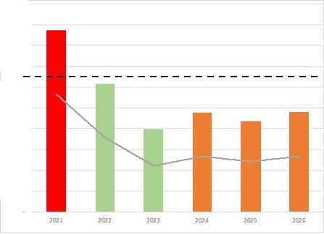

Figure 1.- Annual national deforestation (bars) and of the Amazon biome deforestation (grey line) against Colombia’s deforestation reduction macro-target. NDP 2022-2026. Source: Prepared by IDEAM - SMByC (2024).
This annual report will present the progress of the Programme not based on its five pillars, but according to the Programme’s three results. The report first presents the implementation progress for each of the six NDFyBs, followed by the management actions related to Indigenous Peoples and communities, and finally, the progress made in strengthening territorial entities and national and regional environmental authorities. In addition, the report provides a brief analysis of changes in the implementation context, as well as the challenges and priorities for the coming year.

Deforestation behaviour in 2023 and 2024
Deforestation 2023
For the year 2023, the Colombian territory conserves a natural forest area of 59,187,533 ha, equivalent to 51.9% of the continental and insular territory of the country, highlighting the connotation of Colombia as a country of forests and emphasizing that the country continues to be ranked as one of the 12 countries with the highest forest cover globally, conserving about 1.5% of the planet's forest. The Amazon biome concentrates the largest proportion of natural forest at the national level, identifying that this region conserves about 38.85 million hectares (66% nationally).
In terms of natural forest loss, the monitoring results for the year 2023 identify that in Colombia there was a deforested area of 79,256 ha, continuing the trend of reduced deforestation at the national level, with the lowest figure of forest loss in the last 23 years (period 2000-2023).
With respect to the year 2022, the deforestation figure was reduced in the whole country by 36%, and specifically in the Colombian Amazon biome by 38%. This situation reflects significant progress in meeting the national goals contained in the NDP (National Development Plan) and Colombia's international commitments to mitigate climate change within the framework of the UNFCCC and agreements with donor countries
It should be noted that during the implementation of the REM I Programme, annual deforestation in the Amazon was reduced from 2017 to 2023, 69% from 144,019 to 44,247 ha.
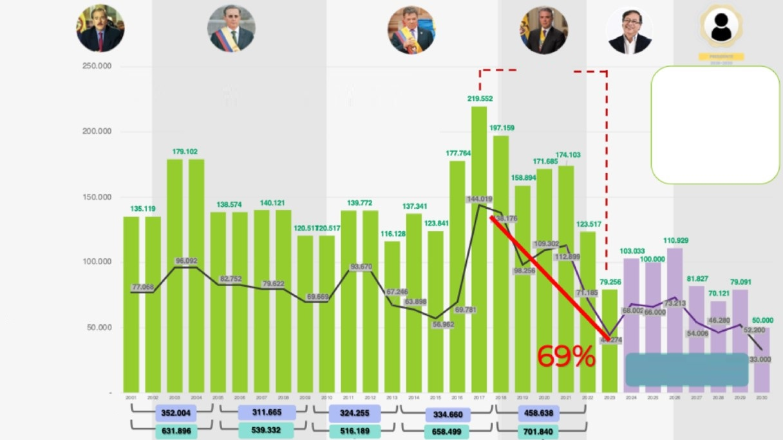
Deforestation in Colombia (ha)
The total forest area in Colombia was 59.5 million hectares in 2021, covering 52.1% of the continental and insular territory, with 66% of it located in the Amazon region

National Historic Deforestation 2001-2023 Total 3'385.649 ha
Average 147.202

Historical Deforestation in the Amazon 2001-2023 Total
1’973.744 ha
Average 85.814

Cumulative Deforestation

ACTIONS BY 2030
Sustainable Forest Model
Carbon Market
Containment Plan
PMB and PNMB Markets
Mobilization of Royalties
Payments for environmental Services and Restoration
Institutional Strengthening
Policy Adjustment /Implementation
Control of Monitoring
Simulated projection to reach net zero deforestation by 2030 to 33,000 hectares in the Amazon
to reach net zero deforestation by 2030, to 33,000 hectares in the Amazon
Nacional Amazonia
REM I
Figure 2. Dynamics of deforested area in the Colombian Amazon - Period 2001 - 2023.
In terms of distribution, by 2023, 61 % of the country's natural forest loss occurred within the jurisdiction of five departments: Caquetá (12,647 ha), Meta (10,310 ha), Guaviare (11,467 ha), Antioquia (8,139 ha) and Putumayo (10,852 ha). Caquetá accounted for 16% of forest loss. It was noted that, in general, the municipalities where the Programme’s activities are being implemented recorded reductions in deforestation, with significant decreases in San José del Guaviare (-3,024 hectares), San Vicente del Caguán (-2,929 hectares), Cartagena del Chairá (-2,189 hectares) and Calamar (-802 hectares).

Table 1. Dynamics of forest loss in municipalities of interest. Period 2022-2023.
Municipio | 2021 | 2022 | 2023 | Diferencia 2022-2023
CARTAGENA DEL CHAIRÁ | 15.841 | 7.373 | 5.184 | -2.189
MAPIRIPÁN | 10.623 | 6.052 | 4.847 | -1.205
CALAMAR | 6.755 | 5.209 | 4.407 | -802
SAN VICENTE DEL CAGUÁN | 15.313 | 6.838 | 3.909 | -2.929
SAN JOSÉ DEL GUAVIARE | 11.325 | 5.938 | 2.914 | -3.024
EL RETORNO | 5.130 | 2.410 | 2.753 | 343
The main direct causes of deforestation in Colombia in 2023, in order of magnitude, were land clearing for land grabbing, unsustainable extensive practices of extensive cattle ranching, unplanned transportation infrastructure development, illicit crop cultivation, illegal mineral extraction, illegal logging, the expansion of the agricultural frontier into unauthorized areas, and biophysical factors (windstorms and landslides), the latter being a notable and emerging factor.
During 2023, 33% of national deforestation was concentrated in 7 main NDFyB: Sabanas del Yarí - Caguán (9.1%); Guaviare (Marginal de la Selva) (7.9%), Mapiripán (Meta) (4.3%); North Central Andean - Northeastern Antioquia/Southern Bolivar (3.5%); North Andean - Catatumbo (2.5%); Llanos del Yarí - Yaguará (2.6%) and Putumayo (2.5%).
Early Deforestation Alerts - year 2024
The behaviour of the estimated deforestation in the first three quarters of 2024 identifies a trend of increase in the estimated deforestation in the 7 departments of the Amazon, registering an estimated deforestation of 48,047 ha, being ostensibly higher than that reported for the same period of 2023 (18,307 ha), with the departments of Meta (+14,481 ha) and Caquetá showing the largest increases (+8,569 ha).
Table 2. Consolidated estimated deforestation in the Amazon, based on early warning reports January - September 2024.
Deforestation Early Warning Bulletin | Quarterly deforestation 2024 in the Amazon (ha) | Quarterly deforestation 2023 in the Amazon (ha) | Increase  (ha)
1st quarter 2024 | 40,219 | 12,042 | 28,177
2nd quarter 2024 | 1,419 | 827 | 592
3rd quarter 2024 | 6,409 | 5,438 | 971
Total | 48,047 | 18,307 | 29,740

Deforestation in Forest and Biodiversity based Development Units
According to deforestation monitoring figures generated by IDEAM's SMByC, for the period 2020-2023 a trend of reduction in deforestation in the NDFyBs in the Amazon is identified. In the case of the six NDFyBs under the responsibility of the REM Visión Amazonía Programme, the same reduction trend is identified.

Table 3. Deforestation reduction trend in NDFyBs

 |  |  | 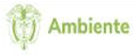 |  | Minambiente  Directorate of Forests, Biodiversity and Ecosystem Services  Institute of Hydrology, Meteorology and Environmental Studies  Deputy Directorate of Ecosystems and Environmental Inf  Forest and Carbon Monitoring System
PUn de Contención de la Deforestación Reporte Superficie deforestada - Periodo 2020-2024*. Núcleos de Desarrollo Forestal y la Btodhersidad (NOFyB).
ID | Region | NDFyB Name |  | Leader Entity |  | Área  Total (ha) | Deforested Area (ha)
 |  |  |  |  |  |  | Year 2020 | Year 2021 | Year 2022 | Year 2023 | Year  2024*
1 | Amazonía | NDFyB Kuway-Nueva York-La Cristalina |  | SINCHI |  | 264.055 | 5.767 | 4.951 | 2634 | 2 679 | 1267.0
2 | Amazonía | NDFyB Charras |  | SINCHI |  | 332.820 | 3.199 | 2396 | 2213 | 1.419 | 823
3 | Amazonía | NDFyB Villa Catalina |  | Corpoamazonia |  | 68.186 | 943 | 685 | 351 | 190 | 176
4 | Amazonía | NDFyB Agua Bonita |  | REM Visión Amazonia-MinAmbiente |  | 251.286 | 3.327 | 3070 | 2 882 | 2 382 | 918
5 | Amazonía | NDFyB Cuemani |  | SINCHI |  | 305 958 | 6241 | 9305 | 4.761 | 3.406 | 4.603
6 | Amazonía | NDFyB Paraíso Amazónico |  | Corpoamazoma |  | 56.802 | 115 | 163 | 147 | 208 | 10
7 | Amazonía | NDFyB Mapinpón |  | SINCHI |  | 642.125 | 8717 | 9459 | 5.161 | 4.015 | 1.874
8 | Amazonía | NDFyB Mecaya |  | Corpoamazonn |  | 131.113 | 1657 | 1.127 | 957 | 981 | 453
9 | Amazonía | NDFyB ElCamuya |  | REM Visión Amazonia-MinAmbiento |  | 157.491 | 4237 | 3 909 | 1.846 | 577 | 1.923
10 | Amazonía | NDFyB Ciudad Yarl |  | REM Visión Amazoma-MinAmbiento |  | 124698 | 4 825 | 7 163 | 2.791 | 2 525 | 2537
11 | Amazonía | NDFyB Llanos del Yari Yaguará 0 |  | Humboldt |  | 198312 | 2 546 | 4.110 | 2236 | 1.707 | 3.160
12 | Amazonía | NDFyB Chuapal - Manavlres |  | COA |  | 57 588 | 1.762 | 1.868 | 834 | 338 | 1.021
13 | Amazonía | NDFyB Anpoleta |  | CDA |  | 138.482 | 5285 | 5291 | 1.803 | 808 | 1.539
14 | Amazonía | NDFyB Las Perlas |  | Corpoamazoma |  | 45.927 | 741 | 663 | 438 | 213 | 61
15 | Amazonía | NDFyB Solano |  | Corpoamazoma |  | 204.182 | 5 356 | 5223 | 2.519 | 1.866 | 1.923
16 | Amazonía | NDFyB Nueva Bostón |  | REM Visión Amazoma-MinAmbíenie |  | 58 822 | 602 | 786 | 346 | 431 | 200
17 | Amazonía | NDFyB Orotuyo |  | REM Visión Amazonia-MinAmbiente |  | 12.495 | 126 | 129 | 42 | 17 | 1
18 | Amazonía | NDFyB Los Puertos |  | REM Visión Amazonia-MinAmbiente |  | 6318 | 2 | 0 | 158 | 235 | 2
19 | Amazonía | NDFyB Cueva del Jaguar |  | SINCHI |  | 221.766 | 2.001 | 2919 | 1.062 | 350 | 217
20 | Amazonía | NDFyB PNN Ttmgua |  | Parques Nacionales |  | 470.128 | 9911 | 11.701 | 7719 | 1.589 | 5.552
21 | Amazonía | NDFyB PNN Sierra de La Macarena |  | Parques Nacionales |  | 959.177 | 8 099 | 9 024 | 5593 | 1 630 | 4.125
22 | Amazonía | NDFy8 Mraltores |  | SINCHI |  | 338 509 | 1035 | 1.183 | 1607 | 1.049 | 547
However, in 2024 there is evidence of increasing deforestation, especially in the NDFyBs of El Camuya and Ciudad Yarí. Therefore, important interinstitutional coordination is required to continue to contain deforestation.

Status of Implementation of the REM Colombia II Visión Amazonía Programme
The following presents the progress of the REM COLOMBIA II Programme in 2024 by result.

Result 1 Forest based Development Units are Implemented within the Framework of an Integrated Strategy for Territorial Intervention.
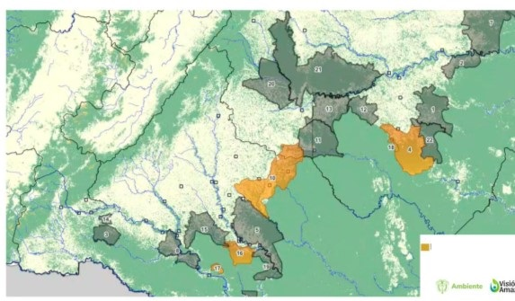
Forest and Biodiversity Development Units
REM Visión Amazonía

Figure 3. Forest and Biodiversity based Development Units in charge of REM II
Based on the experience generated in the Visión Amazonía Programme, Minambiente formulated the "Integral Plan for the Containment of Deforestation" [ICDP] in order to transform the Active Deforestation Cores [NAD for its acronym in Spanish] into Forest and Biodiversity based Development Units [NDFyB], and improve the living conditions of local communities. The Ministry of the Environment prioritized 28 NDFyBs, 22 of them in the Amazon, distributing the intervention portfolio of the different NDF&Bs to SINA institutions (CAR, SINCHI, IAvH, PNN) and international cooperation (GCF and REM). The 22 NDFyBs in the Amazon have an area of 3.2 million hectares, with 2.3 million hectares of forest. In terms of deforestation, for the period 2014 - 2021 these areas correspond to 30% of national deforestation and 50% of deforestation in the Amazon biome, highlighting the importance of their intervention to ensure the effective reduction of deforestation.
Based on social agreements with ethnic and peasant (campesinos) organizations, activities are being developed for the conservation, management and sustainable use of timber and non-timber products, restoration, agroforestry and silvopasture systems and productive reconversion aimed at promoting social, economic and environmental transformation in areas of active deforestation. Engagement strategies are being implemented, such as the Amazon Forest Incentive [IFA], the “Jungle School” environmental education programme aimed at 1000 rural youth, green credits and rural extension services. For the development of the NDFyBs the formulation of Forest Management Plans [PMF] has been contracted for the Agua Bonita NDFyB in the municipality of Calamar, department of Guaviare, and Aguas Claras - Yarí located in the Yarí NDFyB, in the municipality of San Vicente del Caguán, department of Caquetá. The Nueva Ilusión PMF will be expanded by 30,000 ha. However, public order difficulties have prevented access to the PMF areas, so the contracts have had to be temporarily suspended. It is expected that the processes will resume in 2025. With these PMFs in the formulation process and those already finalized in REM I, 613 families will benefit from the possibility of accessing persistent sustainable forest harvesting on 114,092 ha (see Table 4).
Table 4. Hectares under Sustainable Forest Management and Families Involved in Forest and Biodiversity based Development Units- NDFyB
NDFyB | Number of families involved | Area under sustainable forest management (ha) | REM II Investment  (€)
Nueva Ilusión | 144 | 30,000 | 74,153
Ciudad Yari y El Camuya | 162 | 50,000 | 193,533
Agua Bonita | 251 | 18,000 | 112,000
Los Puertos | 23 | 6,092 | (REM I)
Orotuyo | 33 | 10,000 | (REM I)
TOTAL | 613 | 114,092 | 379,686

Pillar 3 of Agro-environmental Development in 2024 implements complementary early activities outside and inside the Unit, with a portfolio related to agricultural extension, land planning, food sovereignty, green financial instruments, innovations and technological development, productive alliances, definition of agroforestry businesses and structuring of projects that can be financed by Royalties from territorial institutions. Once the socialization by villages and NDFyB has been completed, the actions to be followed are established, which can be articulated with the other pillars of the Programme and institutions such as the National Training Service [SENA], Agrosavia, Departmental Governments and municipalities, for a period of one to two years, while the forest extension and complementary activities, as initially mentioned, begin to be monitored. The budget established per family for early interventions is €1 million, to be invested over a period of 1.5 to 2 years with the support of the agricultural extension service, with an estimated initial number of 2000 to 2500 families. Pillar 3 activities in the described unit will assist 1936 families with resources invested in the amount of €1.6 million.

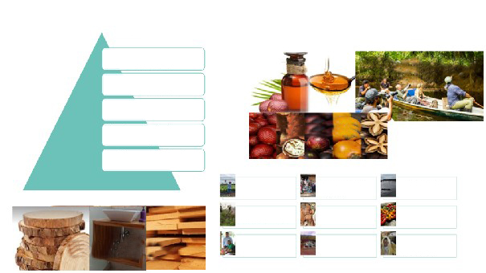
Areas Located in Colonization
Fronts

What are the NDFyB?
With accelerated deforestation procecsses
procese
pro
Deforestation
deforestation processes
With accelerated deforestation processes

Significant forest resources

Accessible by land and/or
river routes
With future growth opportunities
Nature Tourism
Non-Timber
Community Consensus
Ensuring economic growth
Environmental Education

Main activity is the forest component, without being the only one
Social inclusion
Processing centers

Comprehensive territorial vision
Environmental protection
Sustainable use of PMB and PNMB as a conservation strategy

Timber

Figure 4. Description of the Forest and Biodiversity based Development Units [NDFyB]

NDFyB Los Puertos
General data
Location | Calamar, Guaviare
Beneficiary families | 23
Total surface area | 6,318 ha
Forest area | 5,049 ha (80%)
Villages | 2 (Puerto Polaco and Puerto Cubarro)
Forest Management Plan | 6,092 ha
Permit for Persistent Forest Use | CDA Resolution 437 of November 30, 2021

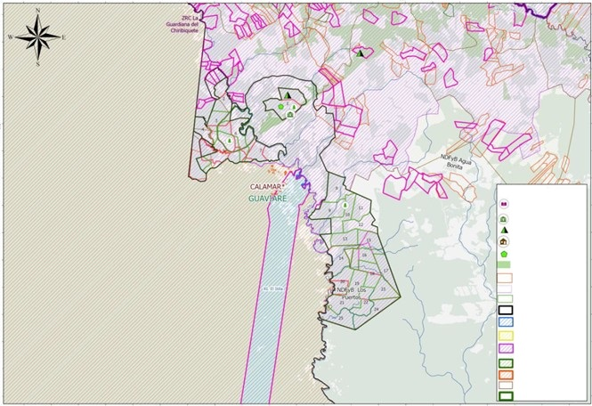
CONVENCIONES
Praes Procedas
Ecosedes
Escuela de selva
Centros de transformación
Aserríos Portátiles
Frontera agricola
Proyectos Agroambientales
IFAS
UCAS
NDFyB
Resguardo indigena
ZRC Constituidas
ZRC Solicitudes
Solicitud resguardo indigena
RUNAP
Limite Municipal
Limite Departamental
Serranía de Chiribiquete
Figure 5. Map of the Interventions in the NDFyB Los Puertos

This unit is located in the villages of Puerto Cubarro and Puerto Polaco, within the buffer zone of Chiribiquete National Natural Park [PNN Chiribiquete], in a colonization front of the municipality of Calamar, department of Guaviare. It covers an area of 6,291 hectares, of which 5,500 hectares are covered by natural forest, and it has both land access from the municipal centre and river access via the Itilla River. In this Unit, the community organized around the Agroforestry Multiactive Cooperative [Cooagroitilla], is laying the groundwork to transition from a cattle culture to a forestry-based culture, where the forest becomes the central element in the process of territorial land use planning and management.
The starting point for this Unit was the formulation of the Forest Management Plan in REM I, which identified: a) more restrictive areas for conservation, b) areas for restoration and c) areas for sustainable forest utilization. Based on this document, the environmental authority CDA issued Resolution 437 of November 2021, which granted a persistent forest harvesting permit, association mode, defining the supply, species, volumes of harvestable timber and silvicultural activities are established to ensure sustainable forest management. This 25-year community permit, the largest in the department of Guaviare, authorized Cooagroitilla to use 115,181 m³of timber from 12 species within 25 Annual Cutting Units [UCA for its acronym in Spanish].
To sustainably achieve the permitted harvest volume, progress is currently being made with the Harvesting Plan, which includes: a) a skidding system that will allow logs to be moved over distances of less than 70 meters from the felling point to the sawmilling site; b) a portable sawmill to be installed within the forest to convert logs into blocks or planks, reduce waste, and obtain quality products — to be contracted with the Foresta Consortium, made up of OFFA S.A.S. and Máquinas Versateis, in the first half of 2025 for €36,476; and c) timber extraction through the installation of a medium-height cable system, which will enable the transport of 10 m³ of wood per day within the UCA — to be executed by the OFFA and Zulu Forest consortium, contracted in December 2024 for €141,598.
Figure 6. Portable Sawing and Cable System for NDFyB Los Puertos

With the purpose of joining value chains, the model is complemented with the construction of a Forestry Transformation Centre in the urban centre of Calamar, with an average capacity of 2,500m³/year, which will generate 30 formal jobs, adding value to a business estimated at 3 billion pesos per year, about €700,000, whose profits will be distributed fairly and equitably among the cooperative's members and in the purchase and maintenance of equipment and investment in community social infrastructure.
In order to comply with the obligations derived from the forest harvesting permit, a Social, Technical and Entrepreneurial Accompaniment Plan [PASOTE for its acronym in Spanish] has been designed, which is the basis of the forest extension pilot project, which seeks to strengthen the Cooperative's technical and operational capacity to position itself as a reliable supplier in the market, improve its living conditions and protect the immense natural wealth in its territory.
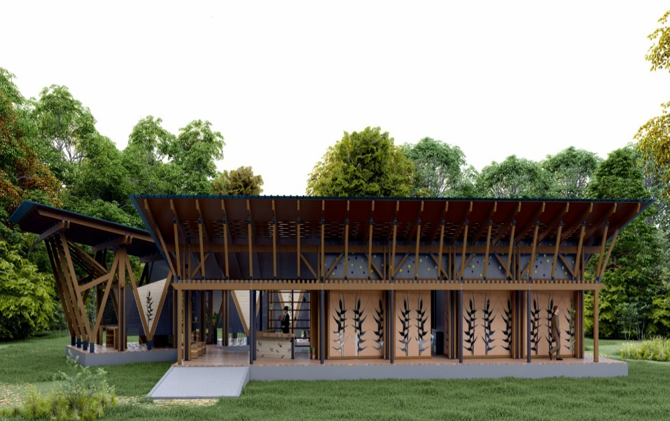
Figure 7. Design of Los Puertos Ekosede
With the purpose of promoting domestic timber consumption, the training programme in woodworking, initiated in 2024 in partnership with the Santo Domingo School of Arts and Crafts, will continue. This programme enabled members of the NDFyB to receive training in joinery, furniture making, and wood carving. To further develop these skills, a theoretical-practical workshop has been designed, allowing students to apply their training in the construction of their EkoSede, located within the perimeter of the first Annual Cutting Unit [UCA]. This facility will use timber harvested from the NDFyB’s forest as its primary structural element and will serve as an appropriate space for staff training, administrative procedures, equipment and timber storage, worker accommodation, food preparation, sanitary units, and other purposes.
In the surrounding areas of the EkoSede, an Environmental Education project led by the NDFyB’s women will be developed. This initiative will focus on restoring part of the riparian buffer of a water body near the EkoSede and enhancing the site with Amazonian plant species.
Additionally, the second phase of the Escuela de Selva² Environmental Education strategy has begun, training leaders and young people as “Community Forest Stewards”, who participate in forest protection efforts and foster values of environmental respect and appreciation. Likewise, training in sustainable forest management skills and competencies is being provided to forest workers through the Faculty of Forestry Engineering at the Putumayo Technological Institute. Complementary to this, Community Forest Monitoring, led by trained local leaders in legislation, forest inventories, species identification, GPS use, and parcel boundary mapping, has enabled the empowerment of local actors regarding the knowledge, use, and conservation of the NDFyB's natural resources.
Finally, another successful strategy that has contributed to strengthening grassroots
____________________________
2 National Environmental Education Award “Augusto Maya Ángel” December 26 2022

communities and curbing deforestation in the unit is the Amazon Forest Incentive [IFA].
This is a temporary voluntary, and additional economic incentive granted to farmers alongside their regular income, awarded when compliance with the commitment to keep the forest standing is verified. This verification is certified by IDEAM's Forest and Carbon Monitoring System. In this NDFyB, made up of 23 associates, only 18 receive IFA by voluntary decision. In 2024, a total of €40,504 was paid to them. The agreement’s effectiveness remains at 100%, with only some deforestation incidents occurring outside the NDFyB.

To ensure that the use of timber products maintains the diversity of the forest, that forest operations are sufficiently profitable and provide incentives to the local population over time to maintain forest resources, it is planned to achieve Forest Certification under the Forest Stewardship Council [FSC for its acronym in English] scheme by 2025. This will guarantee the end consumer that products originating in the Los Puertos NDFyB come from well-managed forests, which is expected to open up better market opportunities and position the Unit as a national pioneer with forest certification in natural forests. To this end, a consulting firm has been hired to assist the Cooperative in complying with the requirements, and the first audit is expected in the second half of 2025.
Given that the families in this group have received different types of support in previous years in REM I, Pillar 3 Agro-environmental does not contemplate implementing early interventions.

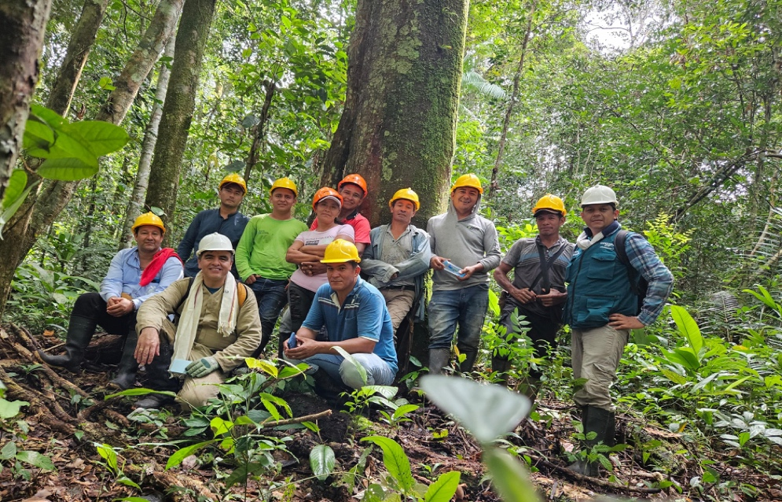
Figure 8. Cooagroitilla in the UCA of the NDFyB Los Puertos

Finally, and to round out the investments in this NDFyB, within the framework of Sector Pillar 2 and with Institute for the Planning and Promotion of Energy Solutions for the Non-Interconnected Areas [IPSE], the consultancy for the formulation and structuring of energy communities in the NDFyB Los Puertos and Agua Bonita began. This consultancy seeks to scale energy solutions that address the present needs of the communities settled in the NDFyBs, prioritizing clean and renewable technologies that minimize the environmental footprint and contribute to climate change mitigation by providing sustainable energy, reducing the use of fossil fuels, strengthening the value chain associated with sustainable forest use. This consultancy is also being carried out in the village of Peregrinos, Municipality of Solano, in the non-municipalized area of Pacoa, Vaupés and in San José de Cananari, Vaupés Resguardo. Once this stage is completed, with funding from IPSE and the Ministry of Mines and Energy [MME for its acronym in Spanish], the results will be presented to secure financing for the implementation and operation phases.

Investments in areas surrounding the NDF:
The mayor's office of Calamar was accompanied to coordinate with other territorial entities a possible work plan for the neighbouring NDFyB of Agua Bonita to stop deforestation along the Calamar-Miraflores road. Through Sector Pillar 2, a contract was awarded to begin the environmental zoning of 240 parcels adjacent to the Agua Bonita NDFyB, taking into account national and regional regulatory instruments. This activity helps the Ministry of the Environment's Land Management Directorate to meet the National Development Plan’s [PND for its acronym in Spanish] goal with respect to Participatory Environmental Zoning.

Table 5. NDFyB Los Puertos Investment Progress (in € )
Components | Appropriation |  | Execution | Local Investment
Forest | 230,818 |  | 38,580 | 35,937
Sectorial issues |  | 75,073 | 24,149 | 10,598
Incentives for conservation and restoration |  | 40,009 | 1,115 | 1,115
Transversal |  | 103 | 41 | 0
TOTAL |  | 346,003 | 63,885 | 47,650

Figure 9. Percentages NDFyB Los Puertos Investment (in€ )

NDFyB Agua Bonita
General data
Location | Calamar, Guaviare
Beneficiary families | 853 farming families, 103 families in 3 indigenous resguardos (Itilla, La Yuquera and Barranquillita)
Total surface area | 251,286 ha
Forest area | 188,647 ha (75 %)
Villages | 17
Forest Management Plan/ Permit for Persistent Forest Use | Management Plan in formulation (18,000 ha)

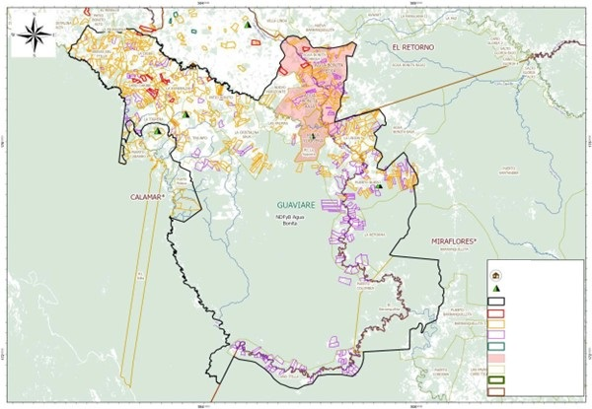
Limite Municipal
Limite Departamental
Veredas
Comunidades Energéticas
Cacaoteros
IFAS
Proyectos Agroambientales
Contratos Derecho de Uso
Núcleos de Desarrollo Forestal
Escuela de selva
Centro Transformación
CONVENCIONES
Figure 10. Distribution of REM II Programme Interventions

Agua Bonita is a NDFyB located in the municipality of Calamar on the left bank of the Itilla River, a tributary of the Vaupés River, northeast of the Serranía del Chiribiquete National Natural Park covering an approximate area of 251,286 ha. Most of the area of this NDFyB is within the municipality of Calamar, with a smaller portion in the municipality of Miraflores. Access is by land from San José del Guaviare.
The NDFyB is composed of 17 villages inhabited by peasant population from different parts of the country, and indigenous communities Tucano, Wanano, Desano, Piratapuyo, Cubeo, Sikuany, Yuruty, settled in the reserves of Barranquillita, La Yuquera and El Itilla, contributing to cultural diversity as the basis of a social agreement that gave life to the NDFyB Agua Bonita.

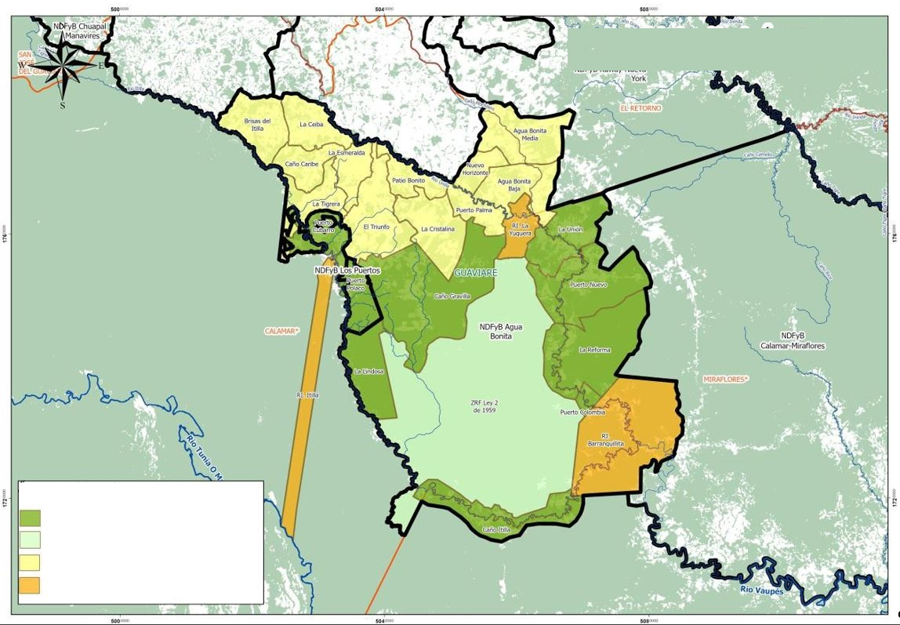
Prioritization of Intervention Areas REM – Visión Amazonía

Áreas de intervención
Sustainable Forest Management Area

Conservation Area

Area for Restoration and Sustainable Production
Indigenous Territorial Areas

Figure 11. Preliminary Zoning of the Agua Bonita NDFyB

According to the characteristics of the existing coverage within the NDF, 4 differentiated intervention zones have been identified:
Northern area (yellow): This is a transformed area with 60% pasture and crops and 40% fragmented and highly degraded secondary natural forest. The main use is cattle ranching with emphasis on dual purpose. This area includes the following villages: 1) Brisas del Itilla, 2) Puerto Nuevo, 3) Agua Bonita Baja, 4) Agua Bonita Media, 5) Nuevo Horizonte, 6) Puerto Palma, 7) La Cristalina, 8) El Triunfo, 9) Patio Bonito, 10) Caño Caribe and 11) La Ceiba. Interventions in this zone are aimed at: forest enrichment, livestock reconversion, agroforestry systems, and agricultural and livestock extension.
Forest Reserve Area (light green): There are no villages or human settlements per se; however, there is significant deforestation in the Caño Gravilla sector. Control and vigilance actions are needed, so it is proposed to analyse the possibility of declaring a regional protected area.
Forest management area (dark green): With forest potential, it is proposed to develop a Forest Management Plan in villages such as Puerto Nuevo, La Unión, La Reforma, Puerto Colombia.
Indigenous Resguardos Area (orange): A Cultural and Environmental Management Plan will be formulated for the Yuquera and Barranquillita and Itilla Resguardos, in accordance with their traditional practices and customs.
Currently, an Associative-type Forest Management Plan, PMF is being developed for 18,000 hectares of forest, with the participation of communities from each of the prioritized villages in the northern zone of the NDFyB. As a result of these participatory processes, a potential area of 4,900 hectares has been identified, corresponding to 123 individuals, with whom the planning and implementation of the forest inventory will begin.

In this NDFyB, working together with ASOJUNTAS Calamar, the corresponding land surveys were carried out and conservation agreements were signed with 400 peasant families from 17 villages and 103 indigenous families belonging to the indigenous Resguardos of Barranquillita, La Yuquera and Brisas del Itilla. Payment of the Amazon Forest Incentive in this NDFyB will guarantee the conservation of 43,033 ha, and is recognized when compliance with the commitment to maintain the forest standing is verified, which is certified by IDEAM's Forest and Carbon Monitoring System.
For territorial planning and in collaboration with the Government of Guaviare, 392 Sustainable Land Use Plans [PPS for its acronym in Spanish] have been developed within the NDFyB, which include a voluntary forest conservation agreement, socioeconomic-environmental characterization, parcel survey, parcel prospecting and technical report. As a tool to support decision-making in terms of land use planning, the information collected is loaded into the FORLAND platform, which integrates spatial information, modelling and data processing.
Leaders and young people from the NDFyB have participated in the Escuela de Selva, which trains "Community Forest Stewards". It is also expected to begin training forest workers in skills and competencies in Sustainable Forest Management in 2025 through the Forest Engineering Faculty of the Technological Institute of Putumayo.
While the Programme continues advancing in the planning of activities such as the management plan and energy communities, among others, a total of 404 families were registered in 2024 for the IFA incentive, through ASOJUNTAS Calamar. In 2024 these families received a total of €909,095, protecting 43,034 hectares that they share with the three indigenous reserves that are part of the NDFyB: the Itilla, La Yuquera and Barranquillita indigenous Resguardos.

Through the Agro-environmental Pillar, early agro-environmental development interventions are expected to begin in 2025 on different topics such as productive projects, agricultural extension, food sovereignty, among others, activities that will be previously agreed upon with the villages. In the northern part of the NDFyB, especially in eleven villages where there are smaller forest extensions, green credits with incentives for forest conservation are expected to be implemented, oriented to productive livestock reconversion as part of the productive restoration. The budget allocation for the NDFyB is COP 2,000 million to be invested over a period of 1.5 to 2 years.

Within the framework of the fourth call of the Environmental Governance Pillar with Indigenous Peoples, two projects were approved in reserves that are part of the Agua Bonita NDFyB. The first is the project “Ecological Restoration through the Sustainable Production of Amazonian Fruits in the El Itilla Indigenous Resguardo, Department of Guaviare”, in the Itilla Resguardo, with an investment of €138,058; and the second is a women-led project “Seeds of Life: Women of the Forest Restoring the Governance of Their People Around Water”, with an investment of €66,727, in the La Yuquera Indigenous Resguardo.
Additionally, under the Agro-Environmental Pillar, with an investment of approximately €100,000, support will be provided to 103 Indigenous families from the three Resguardos, offering assistance on food security initiatives — including sugarcane, cassava, and cacao — as well as generating income through the sale of surplus produce.
In 2025, a safeguarding exercise will be carried out through the construction of Cultural and Environmental Management Plans for the Yuquera, Barranquillita and Itilla Resguardos. This will provide a reference framework for intervention in their territories, in the context of the Life Plans, which were previously supported by the REM Programme. This process will be agreed with the Resguardos in the first quarter of 2025. The route for them is schematically as follows:

Figure 12. Cultural and Environmental Management Plan Route

In order to initiate a process of documentation and agreement on the socio-environmental conflict over the illegal road from Calamar to Miraflores, an active deforestation front, the Sector Pillar began contracting the environmental zoning of 240 parcels adjacent to the Agua Bonita NDF, taking into account the regulatory instruments at the national and regional levels. This intervention is framed within the goals of the PND 2023 - 2026 of the Participatory Environmental Zoning of the Directorate of Territorial Planning of the Ministry of the Environment. Additionally, as in Los Puertos, a consultancy was launched with IPSE for the formulation and structuring of energy communities in the NDFyB Agua Bonita.

Table 6. Progress of investment in the NDFyB Agua Bonita (in € )
Component | Appropriation | Execution | Local Investment
Incentives for conservation and restoration | 1,399,217 | 152,312 | 152,312
Sectorial issues | 221,872 | 24,149 | 10,598
Forest | 163,031 | 64,169 | 61,526
Agro-environmental Development | 130,681 | 73,309 | 73,309
Transversal | 4,635 | 1,852 | 0
TOTAL | 1,919,434 | 315,790 | 297,744

Figure 13. Percentages Investment NDFyB Agua Bonita (in € )

NDFyB Orotuyo
General data
Location | Cartagena del Chairá, Caquetá
Beneficiary families | 85 (33 of the Association)
Total surface area | 12,496 ha
Forest area | 11,188 ha (89.5%)
Villages | 1 (Orotuya)
Forest Management Plan | Sustainable Forest Management Plan, Corpoamazonia, by resolution No. 1221 of October 19, 202 (24 UCAs, 7,224 ha).
Permit for Persistent Forest Use | Permit Corpoamazonia resolution No. 1726 of 2021.

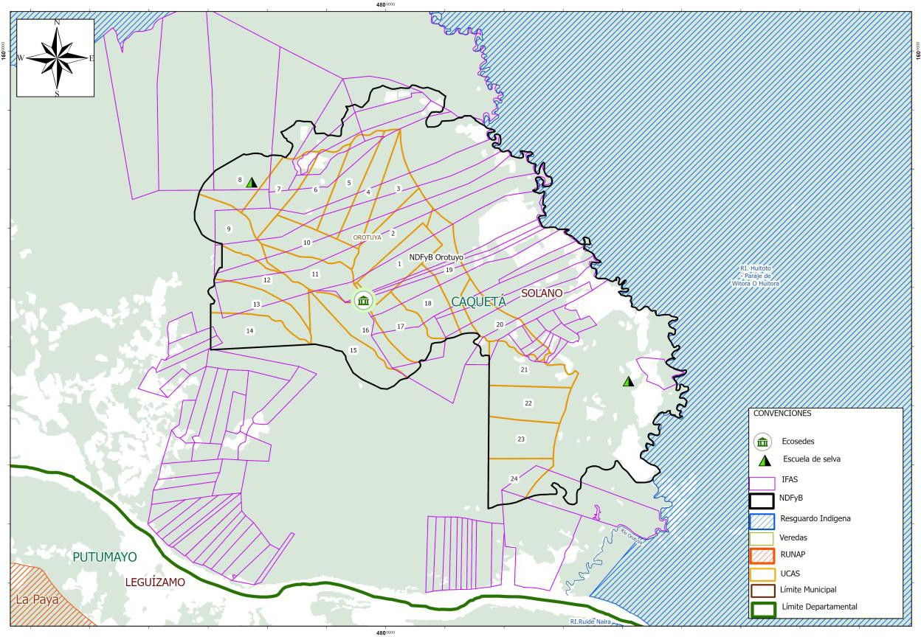
Figure 14. Distribution of the Programme's Interventions in NDFyB Orotuyo

"The Forest is Orotuyo".
NDFyB Orotuyo is located in the village of Orotuya in the municipality of Solano in the Department of Caquetá within the forest reserve area of Law 2 of 1959 of the Colombian Amazon, in a front of peasant colonization, adjacent to the indigenous Resguardos Huitora and Coropoya. This district has recognition of Legal Capacity No. 002 of February 10, 2012, and has a total area of 23,236 hectares.
The consolidation of this area as NDFyB Orotuyo dates back to its main socialization intervention in 2018 due to the concern of permanent deforestation alerts in the municipality of Solano. The local community within its social governance is organized in Association of Forest Development "Orotuyo" integrated by 23 partners established under Minute No. 001 of November 24, 2019. Its mission is to improve the quality of life of the associates, their families and the community in general, promoting sustainable harvesting, processing and marketing of timber and non-timber forest resources.
The NDFyB Orotuyo has a Sustainable Forest Management Plan, approved by Corpoamazonia through resolution No. 1221 of October 19, 2021. This resolution grants a persistent forest harvesting permit under an association model valid for 24 years, with a reserved timber volume of 170,608 m³. The plan enables the planning of persistent forest harvesting on public land over a total area of 10,000 hectares and polycyclic forest harvesting on 7,095 hectares for timber products. It also includes a legal origin recognition scheme and the promotion of sustainable forest management, granted by the same authority through resolution No. 1726 of 2021, for 15 forest species in the ‘Platinum’ category.
This NDFyB has also developed a technical, economic, financial and operational feasibility study to implement a timber product processing centre as a pilot strategy to curb deforestation and strengthen the community-based forest economy. This study was carried out by the REM Colombia - Visión Amazonía Programme. The NDFyB is currently in the preparation phase to obtain forest certification under Colombia’s national standard for FSC.
This NDFyB is made up of 35 families from the municipality of Solano. In 2024, the number of families benefiting from the IFA was increased in order to protect the southern area of the NDFyB. 85 families benefited for a received value of €159,392, conserving 17,220 ha of forest.
One of the most significant interventions of the NDFyB has been the creation of the Escuela de Selva, a response to one of the community’s most pressing needs is education. In this context, the Orotuyo campus of the Peñas Blanca Educational Centre was established in the municipality of Solano, through Resolution No. 000930 of July 25, 2024.
In Phase I of the "Escuela de Selva" educational strategy, seven community leaders were trained as community forest stewards. Currently, 20 students are taking the diploma course in Community Forest Stewards, who completed the training in the Strategic Ecosystems and Sustainable Forest Management module.
Within the framework of productive activities, 22 families have expressed interest in establishing an Amazonian Production Unit with an area of three hectares of Peach palm fruit (chontaduro), under an Agroforestry System [SAF for its acronym in Spanish], which will add up to a total of 62 hectares dedicated to this activity. This project seeks to promote the sustainable production of non-timber resources in the region, contributing to the local economy and the conservation of the natural environment.
The investment is expected to be complemented by implementing early interventions in different areas such as productive projects, agricultural extension or food sovereignty, among others, activities that will be previously agreed upon with the villages. The budget allocation for the NDFyB is COP 132 million to be invested over a period of 1.5 to 2 years.

Table 7. Orotuyo NDFyB Investment Progress (in € )
Component | Appropriation | Execution | Local Investment
Incentives for conservation and restoration | 221,697 | 69,637 | 69,637
Forest | 120,806 | 21,935 | 21,935
Transversal | 2,884 | 1,206 | 0
Agro-environmental Development | 24 | 24 | 24
TOTAL | 345,411 | 92,802 | 91,595

Figure 15. Percentage of NDFyB Orotuyo Investment (in € )

NDFyB New Illusion
General data
Location | Cartagena del Chairá, Caquetá
Beneficiary families | 144  (with the possibility of increasing to 300)
Total area | 58,822 ha
Forest area | 44,578 ha (76%)
Villages | 5 (Naranjales, Caño Sucio, Magdalena, Libertad and Loma Larga)
Forest Management Plan | 30,000 ha, in process of expansion
Permit of use | -

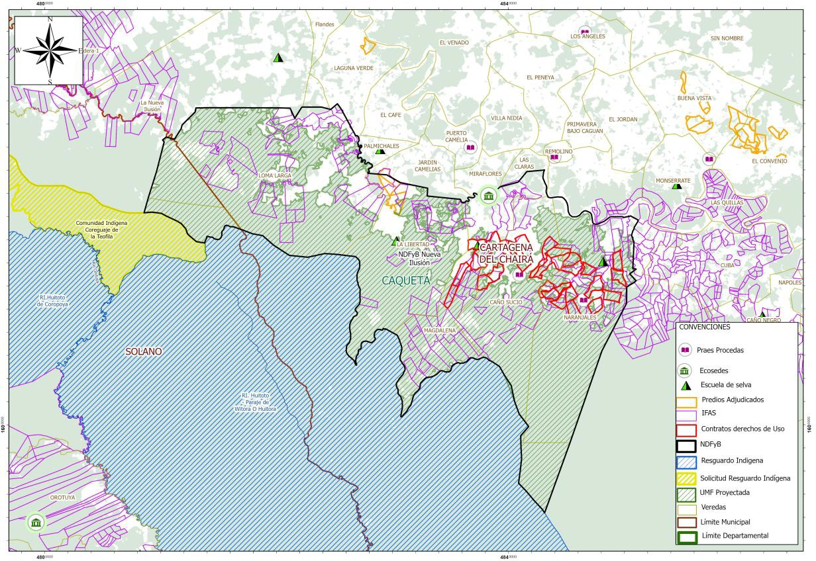
Figure 16. Distribution of Programme Interventions in NDFyB Nueva Ilusión
"Man does not live by cows alone".
The NDFyB Nueva Ilusión is located in the lower Caguán in the municipality of Cartagena del Chairá - Caquetá. It is bordered to the north by the Suncillas River, to the east by the Caguán River, to the south by the Huitora Resguardo and to the west by the municipality of Solano-Caquetá. It is made up of five villages that have a Community Action Board recognized by legal status: Naranjales, Caño Sucio, Magdalena, Libertad and Loma Larga.

In 2019, within the framework of REM I, a participatory construction process began, which was formalized in 2023 when the Forest Development Nucleus Association Nueva Ilusión was formed with 144 families associated with the aim of improving the quality of life of the associates, their families and the community, through sustainable harvesting, transformation and commercialization of timber and non-timber forest resources, ecosystem services, nature tourism, encouraging the support of environmental plans, programmes and projects with community participation and the promotion of biodiversity conservation through the establishment and management of protected natural areas that guarantee the sustainable use of the components of biological diversity.

In 2022 the PMF consortium began formulating the PMF for the Nueva Ilusión Association, and in February 2023 the final document was submitted to Corpoamazonia by the association's legal representative.
However, the Ministry of Agriculture and Rural Development with the National Land Agency [ANT], issued Agreement No. 240 of November 16, 2022, "By means of which the boundaries established in Resolution No. 022 of February 3, 1981 issued by INCORA, are updated and, for the first time, the Huitorá indigenous Resguardo of the Murui Muina (Uitoto) people is expanded, with a parcel of ancestral vacant land located in the municipalities of Solano and Cartagena de Chairá, department of Caquetá". The expansion of the Huitorá Resguardo overlapped with 14,501 ha established in the Forest Management Unit [UMF for its acronym in Spanish] of the NDFyB Nueva Ilusión.
By the end of 2024, a call was made to update, realign and formulate the community PMF of 30,000 ha, the first UCA of 500 ha and the Participative Forest Zoning on 58,821 ha of the NDFyB Nueva Ilusión; it is currently being implemented in the preparation phase.
Through the Environmental Education Strategy, 21 young people from NDFyB Nueva Ilusión are currently enrolled in the Community Forest Management diploma programme, delivered by the University of the Amazon. This programme is aimed at young leaders seeking to transform the legacy of deforestation into a model of sustainable forest management, enabling them to responsibly use the resources their communities have inhabited for generations.
Additionally, Escuela de Selva developed a diploma programme in Woodworking, Furniture and Carving through the Escuela de Artes y Oficios Santo Domingo (School of Arts and Crafts), aimed to train members of the different NDFyB. This training allowed participants to improve their woodworking skills, boost the production of high-quality pieces and promote the sustainable use of forest resources. Furthermore, the initiative strengthened the technical knowledge of the participants, providing them with new opportunities to generate income and consolidate responsible practices within their communities.
The programme is also advancing in training on skills and competencies for Sustainable Forest Management, which will be delivered to forest workers through the Faculty of Forest Engineering of the Technological Institute of Putumayo, along with Community Forest Monitoring, which will be led by locally trained actors in areas such as forestry legislation, forest inventories, species identification, GPS management and land surveying, will help strengthen community knowledge and autonomy. These initiatives will contribute to the responsible use and conservation of the NDFyB’s natural wealth, ensuring its long-term sustainability.
Since the end of 2019, NDFyB Nueva Ilusión implemented the Amazon Forest Incentive [IFA] strategy, designed to strengthen grassroots communities and curb deforestation. This incentive is a temporary economic recognition for farmers, granted only after verifying compliance with their commitment to preserve standing forests. The certification of this process is overseen by IDEAM's Forest and Carbon Monitoring System, ensuring transparency and effectiveness in the protection of Amazon ecosystems. This NDFyB has also been affected by territorial security issues, along with the declaration of the expansion of two indigenous Resguardos which led to geographical changes within the NDFyB and, consequently, adjustments to the forest use units. It has an association composed of 148 families who received IFA payments totalling €277,529 in 2024, as the renewal of conservation agreements was achieved starting in February 2024. As part of the government’s environmental commitments, the Programme also conducted household characterizations, reaching 448 new families with forest conservation agreements. The payments made to these new families in 2024 amounted to €1,008,105, securing 15,459 hectares under conservation agreements.
Beyond the development of technical skills, these initiatives have strengthened the sense of ownership and local governance of forest territories. Environmental education has not only fostered informed decision-making and community leadership, but has also promoted a vision of conservation articulated with sustainable development, building individual capacities, generating resilient community structures, strengthening a bond of co-responsibility between people and the forests they inhabit, guaranteeing the sustainability of these resources for future generations.
With the ANT, in the NDFyB Nueva Ilusión, 35 parcels were identified with an area of 6,633 hectares, susceptible to adjudication because they are located outside the areas of Law 2 of 1959. Their location is important because it helps to shield the interventions that have been previously developed, guaranteeing legal security and the stabilization of rural populations.
With a budget of COP 1.2 billion, it is expected to implement early agro-environmental development interventions with 300 families, in different areas such as productive projects, agricultural extension and food sovereignty.

Table 8. Investment Progress in NDFyB Nueva Ilusión (in € )
Components | Appropriation | Execution | Local  Investment
Incentives for conservation and restoration | 583,293 | 211,508 | 211,508
Forest | 194,357 | 19,545 | 19,545
Agro-environmental Development | 22,736 | 8,918 | 8,918
Sectorial issues | 3,419 | 2,832 | 2,832
TOTAL | 803,805 | 242,802 | 242,802

Figure 17. Investment Percentages of NDFyB Nueva Ilusión (in € )

NDFyB Ciudad Yari
General data
Location | San Vicente del Caguán, Caquetá
Beneficiary families | 360 (Aguas Claras-Yarí)
Total surface area | 124,698 ha of which 43,478 ha are forests (2023)
Forest area | 43,478 ha (35%)
Villages | 11
Forest Management Plan/Permit for Forest Use | PMF Aguas Claras - Yarí (50,000 ha) under formulation

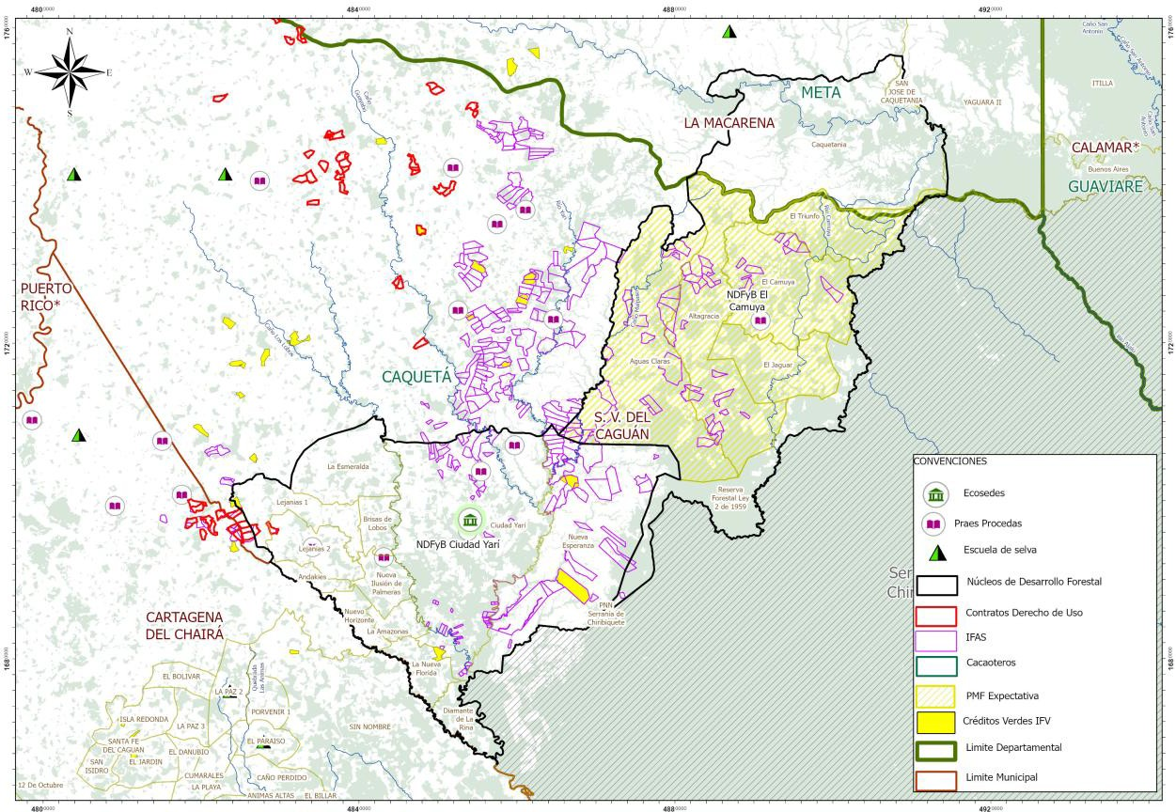
Figure 18. Distribution of Programme interventions in the NDFyB El Camuya and Ciudad Yarí, Caquetá.

"Challenges and Opportunities for Sustainability in Sabanas del Yari"

Originally considered as a single area "Aguas Claras - Yarí", the NDFyB El Camuya and Ciudad Yarí are located in the micro-region known as Sabanas del Yarí, in the municipality of San Vicente del Caguán, bordering the Chiribiquete National Natural Park, in an area of 282,189 hectares, distributed in 17 villages and the Amazonian Indigenous Council (cabildo) La Esperanza. According to the SMByC of IDEAM 2024, by 2023, in terms of conservation, El Camuya had 77,808 hectares, representing 49% of the total area of the NDFyB, while Ciudad Yarí had 43,478 hectares, equivalent to 35% of the total³.
Access to the NDFyB villages is by road from San Vicente del Caguán. At the organizational level, peasant associations, such as the Yarí Farmer’s Business Association [ASECADY for its acronym in Spanish], play a fundamental role, coordinating actions with the Community Action Boards of the villages. The territory has faced historical challenges in several areas: socially, mainly due to public order problems; economically, due to the presence of illicit economies and the lack of productive alternatives; and environmentally, due to continuous deforestation, with the main causes being grassland conversion, extensive cattle ranching, and road construction⁴.
______________________
³ Forest and Carbon Monitoring System [SMByC] of IDEAM, 2024.
The economy of the NDFyB is based on extensive cattle ranching, complemented by plantain, cassava (yuca) and cacao crops, as well as the production of shredded cheese. In terms of education, children attend rural schools, while some young people who continue their secondary education must go to boarding schools due to the long distances or to the municipal capital to finish their studies. In terms of health care, basic services are provided in nearby posts such as Las Damas, Ciudad Yarí and Campo Hermoso, but emergencies must be attended to in the municipal seat. The villages lack electricity, potable water and sewage, relying on solar panels, septic tanks and limited satellite internet.
Recognizing the socio-environmental and economic challenges of the Yarí micro-region, located within the Forest Reserve Zone established by Law 2nd of 1959, the Visión Amazonía Programme began work in 2017 aimed at reducing deforestation, through coordinated strategies with local communities. As part of this process, actions have been promoted such as the formulation of an Action Plan based on proposals from the rural communities of San Vicente del Caguán, the management of funding for local initiatives, the creation of a negotiation ans coordination roundtable, and support for Corpoamazonia in drafting the Action Plan mandated by Ruling 4360/2018. As a result of these participatory meetings and outreach sessions, in 2022 the consolidation of the NDFyB Aguas Claras-Yarí began, covering an area of 508,305 hectares and involving approximately 29 villages. However, in 2024, the Ministry of Environment reduced the area and they were renamed as NDFyB El Camuya and Ciudad Yarí.
Education has been fundamental in Sabanas del Yarí; therefore, through the Forest Governance Pillar of the Visión Amazonía Programme, in 2020, leaders of the territory were trained through the Community Manager Diploma Programme by Escuela de Selva — Phase I. In 2024, the Santo Domingo School of Arts and Crafts offered training in wood carving and assembly for three leaders from the region. In addition, a leader participated in an exchange on sustainable forest harvesting between Colombia and Guatemala, strengthening knowledge of responsible sustainable forest management practices.
In partnership with the Instituto Tecnológico del Putumayo, it is expected that in 2025 training programmes, research initiatives in sustainable forest management, forest certification, and rural housing characterization will begin, thereby contributing to the strengthening of community capacities among people living in the NDFyB.
In addition, the Community Forest Management Diploma Programme is currently being carried out in⁵ San Vicente del Caguán with the support of women leaders, Community Action Boards and ASECADY. The University of the Amazon validated 149 students distributed across three campuses: Villalobos, San Juan de Lozada and 66 students from the NDF of Sabanas del Yarí. These students are currently enrolled in the module titled: "Strategic Ecosystems and Sustainable Forest Management".
_______________________________
⁴ Forest and Carbon Monitoring System [SMByC] of IDEAM, 2024
⁵ The Forest Management Diploma Programme, an initiative of hte Visión Amazonía Programme, is aimed at 1000 young people between the ages of 14 to 32. It began in November 2024 in 14 municipalities of Caquetá, Meta, Putumayo and Guaviare, it includes four modules and is being carried out in partnership with the U. of Amzon.
This NDFyB did not have renewals in the IFA, they maintained the value of COP 300,000 per
month due to the security situation faced in 2024. 201,020 was invested in IFAs in 2024, for 128 beneficiary families (59 families in NDFyB El Camuya, 86 in NDFyB Ciudad Yarí and 123 families in the surrounding areas), who maintained 12,470 ha under forest conservation agreements. Although it is one of the most deforested areas in the Colombian Amazon, the standing forest conservation agreements of IFA beneficiaries were 96% effective.
The public order problems in San Vicente del Caguán during 2024 delayed the execution of actions and activities in the NDFyB El Camuya and Ciudad Yarí. In order to effectively and integrally implement their operation, it is necessary to carry out a Participative Forest Zoning in an area of 508,305 hectares (corresponding to the former NDFyB Aguas Claras - Yarí) and formulate a Community Forest Management Plan. This plan is projected on the NDFyB El Camuya, covering 50,000 hectares, with a first Annual Cutting Unit of 500 hectares.
Despite the challenges in implementing the Forest Management Plan [PMF], efforts have been made — and continue — to directly strengthen and organize the social base. This process includes a business development strategy that will enable the launch of economic activities based on sustainable forest management once conditions allow.
The Programme has remained present and will continue supporting processes aimed at halting deforestation and strengthening the integration of social, economic, and environmental components in the NDFyB El Camuya and Ciudad Yarí. Within this framework, for the years 2025 and 2026, it is planned to advance the Forest Management Plan for El Camuya, while in Ciudad Yarí, management and utilization plans for non-timber forest products will be developed. In parallel, in the border areas of the municipality of Cartagena del Chairá, the Restoration Incentive Areas [AIRE for its acronym in Spanish] will be implemented, with a special focus on women and youth. Additionally, the Sabanas del Yarí are emerging as a strategic destination for nature-based and scientific tourism, promoting conservation, research, and sustainable development strategies. This will be achieved through strategic partnerships, community training, and international promotion, with the goal of diversifying the local economy and positioning the region within the Amazon.
In alignment with these efforts, ongoing environmental education processes will continue, along with the strengthening of social organizations linked to Sustainable Forest Management, ensuring a solid social base prepared for the launch of economic activities based on the responsible use of forest resources.
In line with these efforts, we will continue with permanent environmental education processes and with the strengthening of social organizations linked to sustainable forest management, ensuring a solid social base that is prepared for the implementation of economic activities based on the responsible use of forest resources.
In both NDFyB Ciudad Yarí and El Camuya, each with an estimated 500 beneficiary families, early interventions are expected to be implemented in different areas such as productive projects, agricultural extension and food sovereignty, with a budget of US$2 billion per NDFyB, to be invested over a period of 1.5 to 2 years.

Table 9. Investment Progress in NDFyB Ciudad Yarí (in €)
Component | Appropriation | Execution | Local Investment
Incentives for conservation and restoration | 307,613 | 74,981 | 74,981
Forest | 133,451 | 23,561 | 23,561
Indigenous Governance | 51,629 | 868 | 868
Agro-environmental development | 45,343 | 17,706 | 17,706
Transversal | 2,884 | 1,206 | 0
TOTAL | 540,919 | 118,323 | 117,116

Figure19. Percentages of NDFyB Investment Ciudad Yari (in €)

NDFyB Camuya
General data
Location | San Vicente del Caguán, Caquetá
Beneficiary families | 360 (together with Ciudad Yari)
Total surface area | 157,491 ha
Forest area | 77,808 ha (49%)
Local village (vereda) | 5
Forest Management Plan/ | PMF Aguas Claras - Yarí (50,000 ha) under formulation
Use permit | -

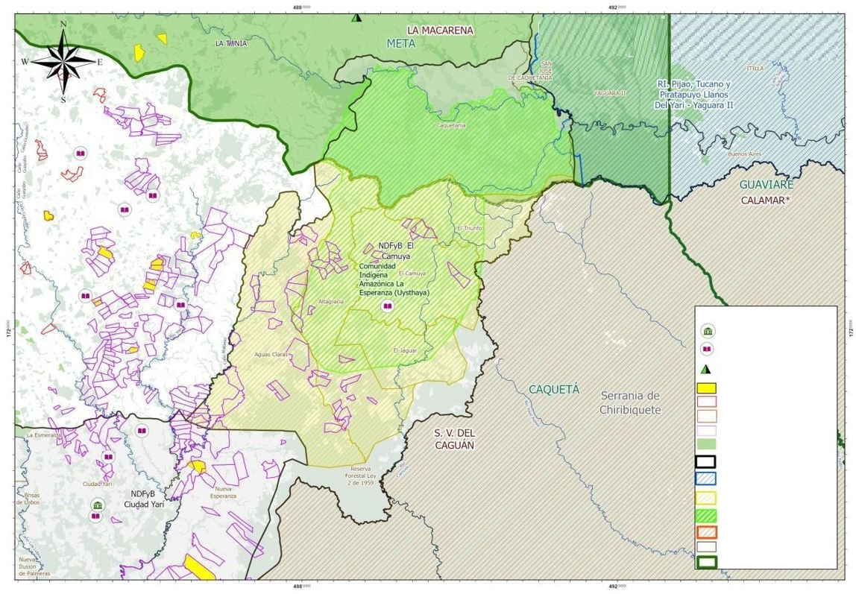
CONVENCIONES
Praes Procedas
Ecosedes
Escuela de selva
Contratos Derechos de Uso
UMF Expectativa
Proyectos Agroambientales
IFAS
IFV
NDFyB
Resguardo indigena
Solicitud de resguardo
RUNAP
Limite Municipal
Limite Departamental
Mapa de Intervenciones Visión Amazonia NDFyB Camuya
Frontera Agricola
Figure 20. Distribution of the Programme's Interventions in the NDFyB Camuya

Table10. Progress of Investment in NDFyB El Camuya (in €)
Component | Appropriation | Execution | Local Investment
Incentives for conservation and restoration | 290,479 | 67,607 | 67,607
Forest | 136,094 | 26,205 | 23,561
Indigenous Governance | 51,629 | 868 | 868
Agro-environmental Development | 45,445 | 17,809, | 17,809
Transversal | 2,884 | 1,206 | 0
TOTAL | 526,531 | 113,695 | 109,845

Figure 21. NDFyB El Camuya Investment Percentages (in €)

Complementary Investments outside the Forest based Development Units
The REM II Programme continues to support certain processes carried over from the first phase of REM. Sectoral Pillar 2 supported the strengthening of nature tourism and birdwatching tourism by providing binoculars, cameras, audio recorders and birdwatching guides for children’s clubs and schoolteachers in the municipalities of Vista Hermosa, San Juan de Arama and La Macarena in the department of Meta; in the same effort, the study of the carrying capacity of the Guape River Canyon, along the Sierra de la Macarena route, is ongoing. In this way, the region is left with a solid foundation for a jungle-based conservation economy, in this case through nature tourism, which began in REM I with Natupaz.
Agro-environmental Pillar 3 implements complementary activities outside the NDFyB with a focus on strengthening value chains initiated during REM I. This includes the completion of the “Cocoa Productivity” project, targeting 135 beneficiaries with activities such as soil analysis, fertilization plans, pruning, the management of new tools, pest control, manual pollination, fertigation systems and zero-deforestation traceability for access to the EU market. It also covers the implementation of an agricultural extension agreement with the Municipality of San Vicente del Caguán to provide technical assistance to 120 Tahiti lemon producers, as well as the marketing of special controlled-viscosity rubber for the national market. Through these activities, both within and outside the NDFyB, the agro-environmental Pillar will reach, 2,957 families with an investment of €8.5 million, including resources from the loan portfolio of Banco Agrario de Colombia.

Amazon Forest Incentive [IFA]
In the first phase of the REM Programme, from 2020 to 2023, the Amazon Forest Incentive [IFA] was implemented as an economic instrument to control deforestation. With a monthly payment of 300,000 pesos against conservation agreements, the IFA focused on the 13 municipalities with the highest deforestation, closing with 2571 families preserving 124,000 hectares of standing forest.
Based on this experience, the Ministry of the Environment created the "Conservar Paga" Programme as part of the management and deforestation control strategy, adopting the IFA as example to develop public policy. This Programme is financed through the Fund for Life and Biodiversity [FVB, for its acronym in Spanish] and is an integral part of the Integral Plan to Contain Deforestation. This plan contemplates the signing of conservation agreements within the NDFyBs with a goal of 16,000 families committed to controlling deforestation. It will be through "Conservar Paga" that the families of the REM Visión Amazonía Programme will be included.
With the implementation of the "Conservar Paga" Programme, it was agreed that the REM II Programme would continue paying the IFA of the Programme's NDFyBs in the amount of 900,000 Colombian pesos per month established by the Ministry of the Environment for the first two quarters of 2024 and would characterize 2235 new families as part of the government's goals, while the Fund for Life and Biodiversity would assume the continuation of these payments starting in the third quarter of 2024.
Due to the difficulties faced by “Conservar Paga” in fulfilling its commitment to cover the IFA payments for the last two quarters of 2024, the Programme, with prior No Objection from KfW, assumed these payments, for an amount of €3,413,840. Of this, Corpoamazonia and Cormacarena made payments amounting to €2,515,949 by December, 2024; however, only €722,159 was formally accounted for, while €1,793,790 was disbursed but could not be formalized in time, and therefore was not officially recorded as executed in the financial report. CDA was unable to make payments totalling €897,891 which will be executed during the first half of 2025.
Thus, from the REM II budget, €4,311,731 was allocated in 2024 and €1,620,050 was executed.
The REM II Visión Amazonía Programme expects to conclude its IFA operations in the first quarter of 2025 reaching 3390 families with 171,640 hectares under standing forest conservation agreements, with IFA payments totalling €6,028,565 (see Table 11). This amount includes €1,716,834 executed in 2024 using the remaining budget from REM I, plus €4,311,731 from REM II. It is particularly noteworthy that, for the first time, indigenous territories were integrated within the framework of the NDFyBs management. With the three indigenous reserves, La Yuquera, Itilla and Barranquillita, which are geographically part of the Agua Bonita NDFyB, collective forest conservation agreements were signed, prioritizing social investments with each of the reserves. It should also be noted that in certain areas, although the REM I Programme stopped paying the incentive when it closed in 2023, its beneficiaries continued fulfilling the conservation agreements with an effectiveness of 98%, making the renewal of these agreements possible.
Table 11. Closing of the IFA Operation
CORPORATION / beneficiaries | Hectares | Families | Total budget  (€)*
CDA | 65,225 | 1,088 | 2,448,255**
RENEWED FAMILIES Guaviare | 22,191 | 581 | 1,307,386
Barranquillita Resguardo | 18,500 | 45 | 101,261
Yuquera Resguardo | 2,455 | 18 | 40,504
Itilla Resguardo | 7,956 | 40 | 90,009
New NDFyB Agua Bonita families | 14,123 | 404 | 909,095
Corpoamazonia | 76,856 | 1,252 | 2,398,937
RENEWED FAMILIES Caquetá | 30,236 | 450 | 1,012,605
New families Cartagena del Chairá (Cueva del Jaguar) | 16,310 | 448 | 1,008,105
San Vicente del Caguán (Camuya - Yari) | 13,052 | 268 | 201,021
Solano (NDFyB Orotuyo) | 17,220 | 85 | 175,331
Villa Garzón (economia de selva farm) | 38 | 1 | 1,875
CORMACARENA | 29,559 | 1,050 | 1,181,373
Mapiripán | 14,755 | 190 | 213,772
Puerto Rico | 6,754 | 398 | 447,797
Vista Hermosa | 5,460 | 325 | 365,663
Macarena | 2,590 | 137 | 154,141
TOTAL | 171,640 | 3,390 | 6,028,565
Source: REM Visión Amazonía 2024 Programme
*Average exchange rate of €1= COP 4,799.5
** CDA failed to meet the commitment of paying €897,891 in December 2024

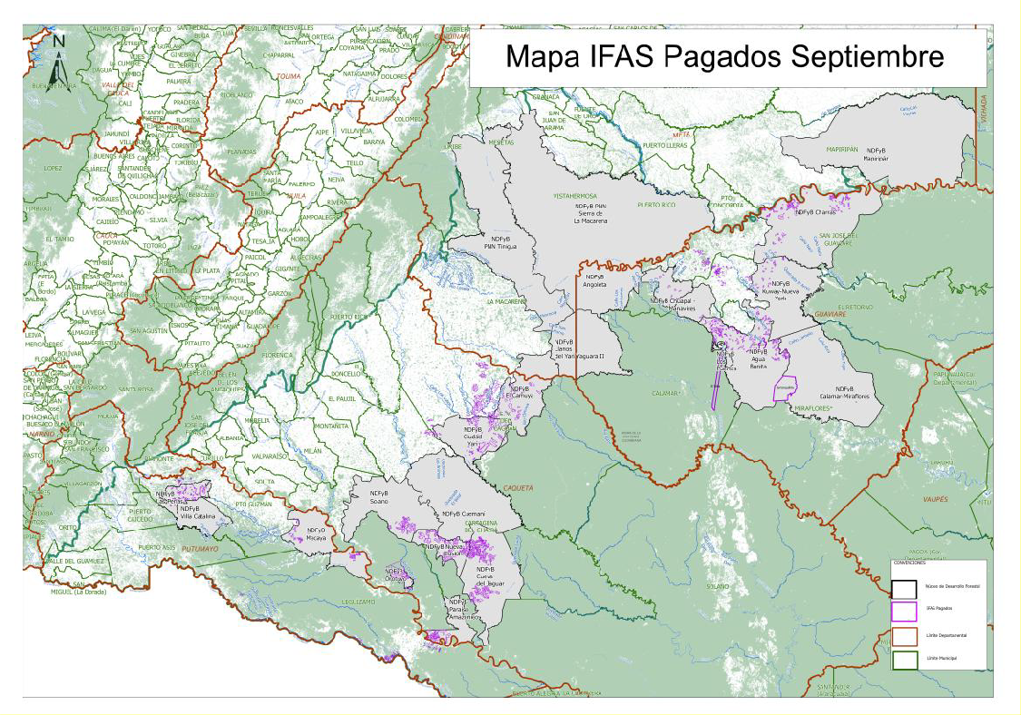
Source: Visión Amazonía REM Programme
Figure 22. Distribution of IFAs paid by the REM II Programme

With respect to the commitment to characterize 2235 new families to be covered by the Fund for Life, this was done through associations of community action boards in the municipalities of Cartagena del Chairá and San Vicente del Caguán (Caquetá) and the municipality of Calamar (Guaviare), In the midst of a challenging public order environment, given this panorama of insecurity, it was not possible to reach the goal agreed with the government, reaching 928 families in Cartagena de Chairá and Agua Bonita, as it was not possible to access the Yarí area, In an effort to restart the Programme in 2025, the boards of the municipality of San Vicente del Caguán withdrew from the conservation contracts owing to various threats. Although the labour formality is temporary, it should be mentioned that the families who signed the standing forest conservation agreements benefited from the change in characterization. These benefits included improved GPS use and the development of survey and report-writing skills.

As shown in Table 12, the REM Programme delivered the characterizations and shape files of the families that have been maintaining the forest for 6 years under agreements with the REM Programme; there are 1928 families that will be part of “Conservar Paga” and will be implemented under the responsibility of SINCHI (Amazonian Institute for Scientific Research), Parques Nacionales Naturales, Corpoamazonia, CDA and IAvH (Humboldt Institute).

Table 12. Conservar Paga Families
Implementing Entity | NDFyB | Number of families
SINCHI | Cueva del Jaguar | 333
SINCHI | Solano | 56
SINCHI | Paraíso Amazónico | 107
SINCHI | Calamar - Miraflores | 37
SINCHI | Kuway – Nueva York | 126
SINCHI | Mapiripán | 190
SINCHI | Subtotal | 849
National Natural Parks | Macarena | 720
National Natural Parks | Tinigua | 140
National Natural Parks | Subtotal | 860
Corpoamazonia | Villa Catalina - Las Perlas | 144
Corpoamazonia | Mecaya | 75
Corpoamazonia | Subtotal | 219
Total |  | 1,928

Result 2 Indigenous Peoples and Communities are Strengthened in their Environmental Governance
2,2,1 Fourth Call for Bids
The Fourth Call for Proposals under the Environmental Governance Pillar with Indigenous Peoples began in January 2024, with the review and adjustment of proposals to amend the Operational Manual and other procedures, as agreed between the REM Programme and the Amazon Regional Roundtable [MRA, for its acronym in Spanish] during Session No, 79, held in December 2023. The main decisions were as follows:
- Adjustments in some administrative procedures provided for in the MOP (Project Operation Manual, for its acronym in Spanish)
- Only indigenous entities could submit projects and implement them
- It was established that the calls for UER Focal Points in PIVA (Indigenous People’s Pillar of Visión Amazonía) should be for indigenous professionals, and that National Organization of Indigenous Peoples of the Colombian Amazon [OPIAC, for its acronym in Spanish] participated in the evaluation through its coordinator in the selection processes,
- OPIAC was to be the organization selected to accompany the selected Indigenous Entities in the administrative and financial processes
- 50% of the resources of the approved proposals were to be led by women
The call was publicly launched on April 4, 2024 and closed on June 6 with a total budget of €6,066,528. A total of 146 projects from indigenous organizations of the Amazon biome were submitted, with 83 proposals for the Women and Family component, which shows the high interest of indigenous organizations and particularly women.
Through the sessions of the Accompaniment Platform [PAS, Spanish acronym], with the participation of all delegates, both indigenous and institutional, 42 initiatives were prioritized and announced by the Minister of Environment and Sustainable Development. The coverage of the proposals includes almost the entire Amazon biome, with initiatives from the department of Vichada, which had not previously participated in the Indigenous Pillar. As an important result of the call for proposals, 57% of the projects corresponded to projects for women.
With the support of six consultants, under the guidance of the focal points, the process of adjusting the projects began in December 2024. The first projects are expected to start implementation in April 2025. This will provide a significant boost to the ownership and implementation of the Programme once the projects are signed and initiated in 2025.

Figure 23. Distribution by Type of Project

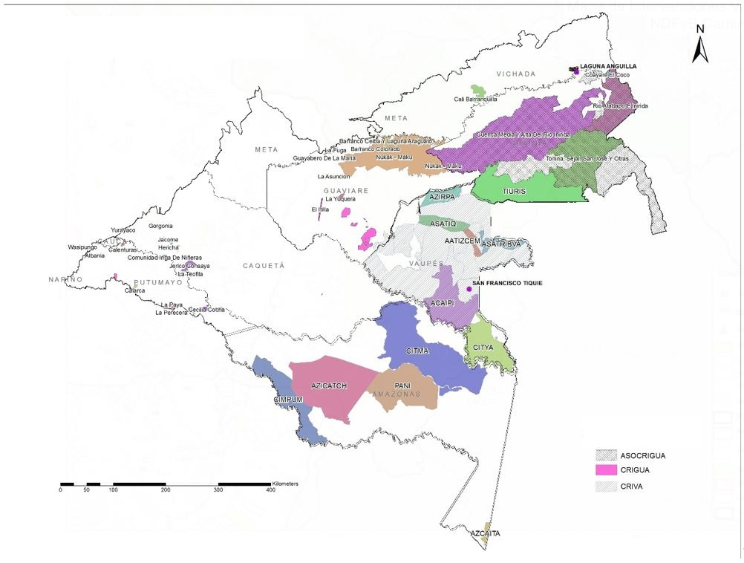
PROJECT COVERAGE – FOURTH CALL

PROYECTOS ORGANIZACIONALES REGIONALES
Figure 24. Distribution of the Projects of the Fourth Call for Proposals of the Indigenous Pillar

It was agreed with OPIAC that once the resources from the United Kingdom are received, the projects that were evaluated in this call for proposals will be financed according to the prioritization list.
Prior Consultation of the Visión Amazonía Programme
As a result of the agreements established during Sessions No. 63 (2021), No. 74 (2023) and No. 91 (2024) of the Amazon Regional Roundtable [MRA] extended to include delegates from the Amazon Indigenous Environmental and Climate Change Roundtable [MIAACC, for its acronym in Spanish] and the Minambiente, it was agreed to carry out the Prior Consultation process for the Visión Amazonía Programme, including the PIVA document (Indigenous Pillar of Visión Amazonía) in order to guarantee this fundamental right of the Amazon Indigenous Peoples in relation to the Programme.
A territorial deployment was carried out involving 23 local dialogue meetings with Traditional Authorities [ATI, for its acronym in Spanish], leaders and other indigenous delegates, distributed in the departments of Amazonas, Caquetá, Guainía, Guaviare, Putumayo and Vaupés; and after them, 9 departmental dialogue meetings were held with ATI guaranteeing the participation of la Bota Caucana, southern Vichada and southern Meta. The documents subject to consultation of the Visión Amazonía Programme were socialized: 1) Base document of the Visión Amazonía Programme; 2) Document of the Visión Amazonía Indigenous People’s Pillar [PIVA] and 3) Efficient and Safeguard Mechanism [MEG, for its acronym in Spanish].
In the 32 meetings (23 local and 9 departmental), shown in the map below, there was a participation of 1,650 people, distributed in 510 women and 1140 men, corresponding to 31% and 69% respectively.
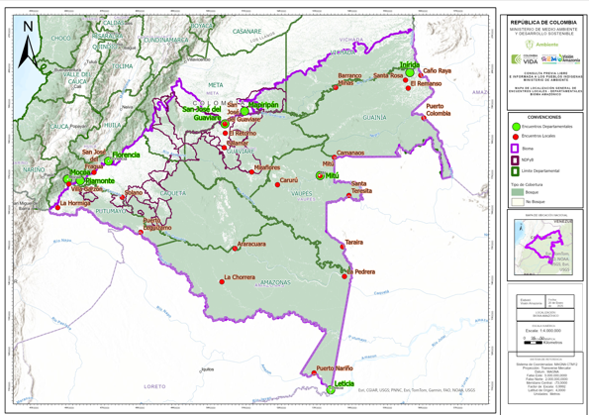
Figure 25. Maps of Meetings Prior Consultation
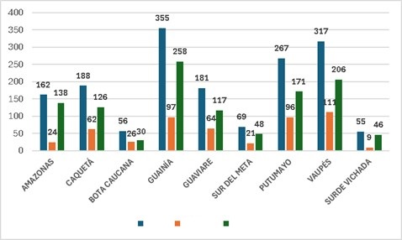
Total
Women
Men
Figure 26. Participation by Gender in the Prior Consultation Workshops
In relation to the participation of indigenous peoples, 71 Amazonian indigenous peoples were present. Figure 6 shows the majority participation of the Curripaco (10%), Puinave (8%), Inga (7%), Murui (7%), Cubeo (6%), Sikuani (5%), Piapoko (4%) and Ñamepako (3%) peoples, which represented 51% of the authorities, experts, leaders and delegates of the organizations that participated in the CPLI (Free Prior and Informed Consultation) of the Visión Amazonía Programme.
With the inputs gathered during the departmental meetings, the political and technical team of OPIAC consolidated a document of the indigenous peoples of the Amazon biome, for dialogue and consultation with Minambiente, in the MRA Session No. 102 held on December 18, 2024.
The most important results that are on the discussion table, and that were presented by the indigenous leaders in the MRA, focus on the proposal to create a Special Indigenous Sub-Programme and participation in the other 4 pillars of the PVA. This proposal includes a redefinition of the PVA Pillars, to incorporate indigenous peoples (see Annex 3). No modifications were proposed to the structure of the Indigenous Pillar Document.
The Indigenous Efficient and Safeguard Mechanism [MEG-I] is a set of, bodies, processes, procedures, mechanisms and criteria aimed at guaranteeing the full, decisive and binding participation of the Amazon Indigenous Peoples at all levels of the PVA governance framework. This mechanism ensures that the Indigenous Peoples have: active participation in decision making; direct access to resources; autonomous management of projects in all phases; decision-making and implementation capacity in the environmental management of their territories.
It should be noted that this process was initially expected to be concluded and the Prior Consultation formally protocolized in December 2024. However, this was not possible due to the limited time Minambiente had to review the proposals submitted by the Indigenous Peoples, which were ultimately presented on the same day as the protocolization MRA session. Additionally, the process was affected by the demands of two Indigenous Peoples who did not feel included in the process. In this sense, a route was agreed to rectify the requests, as well as to analyse and present the Ministry of the Environment's counterproposal to the Indigenous Peoples, culminating in a MRA for the protocolization of the CPLI of the Visión Amazonía Programme, by the end of March 2025. The Ministry of the Interior is being consulted to agree on the route to complete the consultation in the first half of 2025.
It is important to note that the REM Visión Amazonía Programme contributed approximately €500,000, in addition to the GCF (Green Climate Fund) project’s contribution of COP 3,200,000,000. These funds were allocated to support the implementation of this field deployment process, cover fees for OPIAC staff and other expenses, as well as to hire seven professionals for the Minambiente to coordinate and provide support for the Prior Consultation process.

Result 3 Territorial Entities and National and Regional Environmental Authorities Strengthened in Forest Management and Governance and in Monitoring Deforestation
Under Pillar 1 Forestry, support was provided to the Sustainable Development Corporations [CDS, for its acronym in Spanish] Corpoamazonia, CDA and CORMACARENA for natural resource control and surveillance, certification support, and support for the Forest Committees, with an initial investment by Corpoamazonia (EUR 144,187), CDA (EUR 102,991), and CORMACARENA (EUR 102,991). Coordinating professionals for monitoring and control teams were hired, along with administrative-accounting staff responsible for preparing the administrative and financial reports of the Specific Minute, as well as for selecting the technical staff forming part of each monitoring and control team by Sustainable Development Corporation. The personnel hiring was distributed as follows: Corpoamazonia (15), CDA (13) and CORMACARENA (10). Table 13 presents the monitoring and control activities carried out by the Corporations during 2024.
Table 13. Activities Developed in Monitoring and Control during 2024
MONITORING AND CONTROL ACTIVITIES | CORPOAMAZONIA | CDA | CORMACARENA | Total
Reports of illegal logging | 92 | 10 | 221 | 323
Control of timber transport-seizures | 276.53 m³of wood | 1.2 m³of wood | 2 m³of wood | 279.73 m³of wood
Control Checkpoints | 102 | 47 | 32 | 181
Monitoring of companies | 23 | 7 | 5 | 35
Sanctioning processes | 29 | 130 | 22 | 181
Training for the community | 1343 people | 60 people | 470 people | 1873 people
Training for institutional monitoring and control staff | 643 employees | 292 employees | 710  employees | 1645 employees
Source: As reported by the CSD
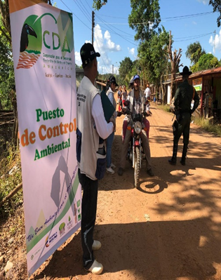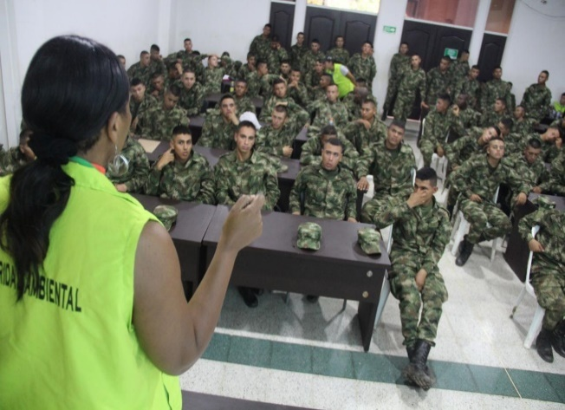
Figure 27. CDA Checkpoint, Training to Public Force
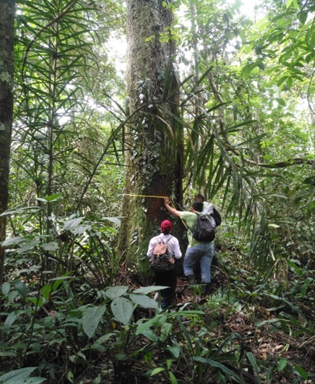
Figure 28. Deforestation Monitoring, Forest Use Monitoring

In support of the Departmental Forest Roundtables of Amazonas, Caquetá, Putumayo and Guaviare, four Forestry Engineers were hired to work on institutional strengthening in relation to the Forest Management Plans [PMF, for its acronym in Spanish], and on training and capacity-building in forest development. Support was also provided for the dissemination of early deforestation alerts, and a map of actors in the forestry sector was produced for each department, identifying a total of 549 actors, with trade associations representing the largest share, followed by institutional actors and forestry sector companies.
Pillar 2 Planning and Sustainable Sector Development supported 7 municipalities in Guaviare, Vaupés and Caquetá in formulation of their Municipal Development Plans [PDM, for its acronym in Spanish] for the period 2024-2027, which have been approved by their corresponding Municipal Councils. These plans included programmes and actions to reduce deforestation and promote the forest economy in the corresponding NDFs.
Nature tourism and bird watching tourism was strengthened by ensuring the provision of equipment such as binoculars, cameras, tape recorders and birdwatching guides, for environmental education groups of children and school teachers in the municipalities of Vista Hermosa, San Juan de Arama and La Macarena. As part of the same initiative, the carrying capacity study of the Guape River Canyon, along the Sierra de la Macarena route, continues to be carried out.
As previously mentioned, coordination with the National Land Agency [ANT] resulted in the completion of the topographic survey of 12,000 hectares, corresponding to 205 parcels. The target of the agreement with ANT is to formalize up to 412 parcels, covering approximately 30,000 hectares. During the first half of 2025, it is expected that ANT will issue the first 50 land titles for parcels located outside the areas governed by Law 2. In partnership with ANT, a total of 273 parcels within the NDFyBs and 146 outside the NDFyBs have been characterized (see Table 14).

Table 14. ANT Beneficiary Parcels within NDFyBs
NAME OF THE NDFYB | PARCELS | Area (Ha)
Paraíso Amazónico Forest and Biodiversity based Development Unit | 46 | 6503.50
Ampliación Nueva ilusión Forest and Biodiversity based Development Unit | 37 | 4678.00
Nueva Ilusión Development Unit | 35 | 6633.00
Charras Forest and Biodiversity based Development Unit | 34 | 3671.00
Macaya Forest and Biodiversity based Development Unit | 2 | 110.00
Kuway-Nueva York Forest and Biodiversity based Development Unit | 35 | 3450.03
Solano Forest and Biodiversity based Development Unit | 23 | 1709.70
Sierra de La Macarena Forest and Biodiversity based Development Unit | 43 | 3252.88
Cuemaní Development Unit | 18 | 2352.00
 | 273 | 32360.11

To support the control of illegal mining in the CDA's jurisdiction, we are hiring equipment and professional personnel, which will enable the reconversion of labour and technological practices used in illegal mining, reduce environmental impacts on water ecosystems and contribute to the control of deforestation,
Apart from the consultancy for the formulation and structuring of energy communities mentioned in the NDFyB of Agua Bonita and Los Puertos, work also began with IPSE in the village of Peregrinos, Municipality of Solano, and in the non-municipalized area of Pacoa, Vaupés, as well as in San José de Cananari, Vaupés Indigenous Resguardos.
Finally, it is worth noting the funding provided for the Environmental Land Use Planning System [SPPA, for its acronym in Spanish] in the department of Guaviare, and participation in regional workshops with the European Union to support compliance with comply the regulation on zero-deforestation traceability for entry into the EU market.

Within the framework of Law 1876 - National Agricultural Innovation System [SNIA, for its acronym in Spanish], the Programme supported the preparation of Departmental Agricultural Extension Plans [PDEA, for its acronym in Spanish] in the departments of Guainía, Vaupés, Amazonas, Putumayo, Caquetá and Guaviare.
Progress was made in the design of a new financial instrument called Productive Restoration "RePro", which will be financed by the Ministry of the Environment and Banco Agrario de Colombia [BAC], in order to promote the conversion of livestock in the Amazon region as part of the landscape restoration activities and its biodiversity, contemplated in the National Restoration Strategy 2023 - 2026 [ENR, for its acronym in Spanish], an institutional management instrument with guidelines for meeting the goal of establishing 753,783 new hectares under restoration processes. With this financial instrument, a new green credit will be obtained, an activity included in the Visión Amazonía portfolio. It is expected to place at least 1000 new credits, similar to REM I, where 1140 credit operations were obtained for COP 17.6 billion, with 24,498 hectares of forest under forest conservation agreements and 25,765 areas under agro-environmental intervention.
Peer review processes and independent measurements of the SMByC: The methodologies, protocols and data produced by IDEAM's Forest and Carbon Monitoring System [SMByC] have not only received national recognition, but have also been evaluated and certified at the international level. The information generated by the SMByC has been validated and verified through peer review processes, which include the estimation of the confidence level for spatial data on forest cover and deforestation. These validation and verification processes are carried out within the framework of Colombia’s Climate Change reports submitted to the United Nations Framework Convention on Climate Change [UNFCCC] by the UNFCCC roster of experts; independent international verification of the REM Payment by Results Programme and the statistical quality certification processes of the National Administrative Department of Statistics [DANE]. In terms of the Forest Reference Emissions Level, the third reference level was submitted in January 2024 and the evaluation report of the Roster of Experts of the Convention on Climate Change was finalized (June 2024) and is expected to be published soon..

Communications Strategy
This year the Programme's web page, hosted within the Minambiente portal, was updated to differentiate the contents of REM I and REM II. To differentiate the REM Programme from other Programmes within the framework of Visión Amazonía. In the second half of the year, a change was made to the visual image of the publications, incorporating the word REM in the logo.
One of the greatest achievements in terms of communication this year was the participation in COP 16, where the REM Colombia Visión Amazonía Programme achieved significant visibility. With a stand transformed into a permanent classroom and a green area featuring and artistic piece representing the Amazon’s flora and fauna, the programme showcased the historic reduction in deforestation. Additionally, programme spokespersons took part in over 50 academic events, presenting the progress made.
In terms of publicity, the year closed with a total of 9 local radio stations contracted in the departments of Putumayo, Caquetá and Guaviare, in the municipalities with the highest deforestation rates. Through these stations, and at the request of the Minambiente, radio spots were aired to support the media plan, featuring testimonials about productive reconversion and conservation.
The high audience Programme in Caquetá, Enfoque Caquetá, was also contracted. Through its live broadcasts on the Ondas del Caquetá radio station and on Facebook, it interviewed spokespersons from REM Visión Amazonía and covered the programme’s activities. In addition, with the support of Guaviare environmental influencer Pipe Q-ida, efforts were made to amplify the REM Visión Amazonía’s key messages. All members of the Guardianes de Chiribiquete environmental collective, led by him, also supported the task of increasing the programme’s impact and reach on social media.
The year closed with the 171st edition of the podcasts broadcasted on the radio stations and social networks and the 65th edition of the biweekly newsletter Territorio Jaguar.
Despite the complex public order conditions in some regions, we continued to cover key news, including: delivery of the Chiribiquete Cross, the highest distinction awarded by the municipality of Calamar to the programme; second phase of the Escuela de Selva programme; mayors' commitments to conservation in their municipal development plans; signing of a framework agreement with the Mayor's Office of Cartagena del Chairá within the framework of the Municipal Council for Rural Development; projects on forest certification in the NDFyBs; COP 16 participation on Biodiversity; participation in Interzum, the legal wood trade fair; delivery of forest firefighting equipment to volunteer firefighters; progress in the NDFyBs.
As for social networks, the following are the numbers of followers at the end of 2024:
Table 15. Followers by Social Network
SOCIAL NETWORK | # FOLLOWERS DECEMBER 2019 | # FOLLOWERS DECEMBER 2020 | # FOLLOWERS DECEMBER 2021 | # FOLLOWERS DECEMBER 2022 | # FOLLOWERS DECEMBER 2023 | # FOLLOWERS DECEMBER 2024
Facebook | 2,887 | 9,217 | 11,132 | 12,619 | 14,102 | 15,911
Twitter | 2,260 | 3,757 | 4,800 | 5,400 | 5,844 | 6,251
Instagram | 4 | 1,205 | 1,927 | 2,358 | 2,795 | 3,333
YouTube | 0 | 319 | 415 | 516 | 629 | 867
Spotify | 0 | 0 | 0 | 12 | 64 | 111
LinkdeIn | 0 | 0 | 0 | 0 | 0 | 3,060
The growth on LinkedIn is noteworthy, where more than 3000 followers were reached with publications on job announcements, tenders and the Territorio Jaguar newsletters, which have had a high impact on the digital community. It is recommended to continue promoting this network to strengthen the presence in the market of experts on environmental issues, climate change and the Amazon.

Questions, Complaints and Claims Mechanism Prior Consultation of the Visión Amazonía Programme
During the period covered by this report, a total of 87 requests were received, corresponding to 31 petitions and 56 requests for information through the Ministry of the Environment's correspondence system ARCA and by mail, visionamazonia@minambiente.gov.co.
It is important to clarify that the requests received do not differentiate between the REM Programme I and REM Programme II, as they are addressed to the Programme in general and its actions within the Amazon Biome. The main topics of the requests involve inquiries about the methodology the Programme has used to ensure safeguards. Another topic that generated a significant number of requests in the first half of the year was interest in participating in the fourth PIVA call. During the second half of the year, over 10 requests were received regarding delays in IFA payments. These concerns were addressed in the responses, explaining the work carried out with the environmental authorities and the Programme to cover pending payments to beneficiaries as soon as possible. Additionally, questionnaires were received from the Congress of the Republic and oversight entities regarding the Programme’s actions and results in controlling deforestation in the Amazon.

REM Execution Unit [UER]

UER Team
In the first half of 2024, the EBU team has 34 professionals, which highlights the strengthening of its administrative structure, led by a Management Leader. This section has an accounting professional, a legal professional, a procurement professional, a logistics assistant, a coordination assistant and a procurement support, which has allowed streamlining administrative, legal and accounting processes. In addition, 2 focal points were hired, from NDFyB Agua Bonita and Yarí, and an indigenous focal point for Pillar 4. Staff members who had previously been working under service contracts were incorporated through employment contracts, including the risk management and safeguards officer, the graphic designer and the community manager.
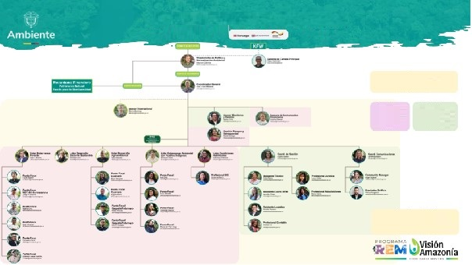
REM II Organizational Chart
Equipo UER
34 cargos
Technical Team 65%
Operational Team 35%
UER Team
Female 17
Male 17
Figure 29. Updated REM Colombia II Programme Organizational Chart

Programme Coordination Spaces
The Programme Coordinator has held regular meetings with the Minister and has participated in the Amazon Coordination Cabinet, where the REM Programme has continued to contribute to strategic issues such as the Integrated Plan for Deforestation Control, particularly with the NDFyBs, the monitoring system of the institutes, the Amazon Forest Incentive as a basis for the Conservar Paga Project and the strengthening of the start-up of the Fund for Life and Biodiversity. In particular, the IFA experience has been transferred to the Conservar Paga Programme of the Fund for Life and Biodiversity.
During the period covered by this report, weekly monitoring meetings were held with the UER and FPN (Natural Heritage. Biodiversity and Protected Areas Fund) to review the Programme's budgetary and technical execution. In addition, several strategic planning meetings were held to coordinate interventions in the NDFyBs among the different pillars. Meetings were also held with Corpoamazonia in Mocoa and with the CDA in San José del Guaviare, to prioritize the intervention in the respective NDFyBs.
Five monitoring committees were held with the Ministry of the Environment, chaired by the Vice-Minister of Environmental Policy and Standardization, with the participation of the directors of key areas of the Programme:
- At the Committee meeting held on February 20, 2024 the unification of all call resources for the fourth PIVA call was approved. Additionally, an increase in resources was authorized for the Amazon Forest Incentive [IFA], School Environmental Projects [PRAES, for its acronym in Spanish] and Amazon Production Units [UPAZ, for its acronym in Spanish]. Likewise, the update of the Monitoring Committee Regulations was adopted.
- On March 15, an extraordinary Monitoring Committee meeting was held to make preventive decisions in response to the delicate situation regarding public order and messages received from armed groups concerning the Programme.
- At the Committee meeting on June 11, it was approved that the REM Visión Amazonía Programme would assume the pending financial balances of three Indigenous organizations. Likewise, the creation of a new line for forest fire prevention was authorized to support 13 municipalities in the deforestation arc.
- On September 9, prior to the IV Executive Committee and KfW Monitoring Mission, a Monitoring Committee meeting was held in which the Disbursement Investment Plan [PID III] was approved.
- The last committee of the year 2024 was held on December 4, where it was authorized to create a new line in the PAD [Disbursement-based Procurement Plan] to transfer resources and complete the payment of the IFA in Corpoamazonia and increase the resources of the Fourth PIVA Call.
Between September 11 and 19, 2024, the KfW Monitoring Mission took place, with the participation of representatives of the Government of Colombia, KfW, the Embassies of Germany, Norway and the United Kingdom, the UK International Forests Unit [DESNZ and FCDO], the Financial Mechanism and the UER of the REM Colombia II Visión Amazonía Programme. The main objective of the mission was to supervise the financial closure of the REM I Programme and to evaluate the technical and financial progress of the REM Colombia II Programme. As part of this agenda, between September 15 and 18, a visit was made to the department of Guaviare to learn first-hand about the experiences of the NDFyB Los Puertos and Agua Bonita. Unfortunately, it was not possible to visit the NDFyB of Los Puertos due to public order problems.
Within the framework of the Mission, the IV Executive Committee of the Programme was held, in which the closing of the REM I Programme was presented, the progress of REM II was socialized and the Disbursement Investment Plan III was submitted for approval, which was unanimously approved by the members in attendance.
On April 24, a Finance Committee meeting was held to present the progress made in closing REM I and monitoring the financial investments of the REM II Programme, as well as the awarding of the REM II Portfolio Manager to Banco de Occidente. At the Finance Committee on August 21, 2024, the balances of the REM I accounts were presented, as well as the delegated portfolio. The transfer of resources from REM I to REM II was approved, with a note requesting KfW's approval. The last Financial Committee was held on December 5, 2024, where the liquidity needs for the current period were presented. The monetization rate for PID 3 resources was defined, and the immediate monetization of 50% of the total amount deposited in the account, was approved.

Finally, in the last months of the year, meetings were held with various environmental NGOs and the technical directorates of the Ministry of the Environment to strengthen the coordination of interventions in the Amazon region. These spaces allowed for the exchange of perspectives, the identification of synergies and the coordination of strategies to ensure more efficient and sustainable management in the region.

Synergies with other Cooperations
The Programme held several meetings with other projects and cooperation representatives, such as with the United Kingdom and Norway, as well as with the Swedish Embassy. The Financial Contribution Contract has been signed with the United Kingdom for an amount of 14.4 million Sterling Pounds. The addendum to the Separate Agreement and the preparation of the PID and PAD IV are expected to be signed in the first half of 2025 and the first disbursement from the United Kingdom for 7.2 million Sterling Pounds (approximately € 9 million) is expected to become viable.
The coordinator participated, together with the Minister of the Environment, in the Oslo Tropical Forest Forum in June 2024. Ongoing coordination has been maintained with KfW offices in Bogota and Frankfurt to report on issues such as the impact of security conditions on programme implementation in the territories where the programme operates, budget-related matters, and the Monitoring Mission for September 2024. In June, a training course on KfW guidelines was conducted for the staff of UER and FPN. Additionally, future alternatives for the Programme have been presented, given the start of operations of the Fund for Life and Biodiversity.
Within the framework of the COP 16 of the Convention on Biodiversity, held in October in Cali, the Programme organized an International Forum with the participation of delegations from Germany and Norway, to present the Programme's intervention strategy. In addition, delegations of parliamentarians and embassies from both countries were received at the Programme's stand.

Programme Risk Management and Safeguards
During the reporting period, the Programme developed several actions from its socio-environmental management, aligned with the Environmental and Social Management Framework [ESMF]. In addition to implementing the Environmental and Social Management Plans [ESMP] for the various interventions, such as the Green Financial Instrument [IFV for its acronym in Spanish]. Amazonian Forest Incentive, forest harvesting in the NDFyBs, progress was made in strengthening the ESMF instruments and monitoring the public order situation in the work areas, contributing to their analysis and documentation.
In 2024, security in the Colombian Amazon was affected by the proliferation of illegal armed groups, both those with political status and those focused on illicit economies. The former experienced internal fragmentation due to disagreements with the position taken by their representatives at the negotiation tables with the Government, leading to territorial disputes, armed clashes, and pressure on local communities. In this context, the main risks identified included threats to the personal safety of the Programme’s team, partner organizations, community leaders and beneficiaries; impacts on the continuity of the processes and fulfilment of agreements; and an increase in deforestation.
To mitigate these risks, the Programme carried out constant monitoring and information gathering on safety with local stakeholders, strengthened the social appropriation of safety processes and protocols, involved local personnel in the interventions and adapted work plans according to specific conditions. In addition, the Workplace Prevention System was reinforced through the consolidation and socialization of a publication on the management of situations in field work and a cycle of training on this topic was carried out in alliance with the Human Resources area of the Fondo de Patrimonio Natural (Natural Heritage Fund).
In November, the Stakeholder Participation Plans [PPPI] for the NDFyB Los Puertos - Agua Bonita was resumed after having been suspended several months earlier due to security concerns. As a result, it is expected to consolidate a PPPI with a methodology that can be replicated in other NDFyB sites, develop the Indigenous Peoples Framework and design tools for intercultural dialogue, with a planned completion date of May 2025.
Within the framework of the Internal Committee for Socio-Environmental Safeguards of the Ministry of Environment and Sustainable Development [CISSA for its acronym in Spanish], the Programme contributed to manage and provide technical support for the consolidation of the VI Summary of Safeguards Information [RIS VI], published in September 2024 in the UNFCCC's REDD+ hub. Likewise, in this space, a roadmap was proposed and adopted for the development of RIS VII, currently under execution, and the Programme participated in the technical sessions for the regulation of safeguards- a government commitment established in Article 230 of the National Development Plan [PND].
In order to contribute to environmental governance in the area of the NDFyB Nueva Ilusión and Orotuyo, which border indigenous Resguardos, progress was made in developing a roadmap for the establishment of intercultural agreements between peasant and indigenous communities in the area of mid-Caguán and mid-Caquetá, in collaboration with The Nature Conservancy [TNC]. This process is scheduled to begin in May 2025, with the participation of entities, NGOs and social organizations present in the area.
On the other hand, requests were identified for the constitution of indigenous reserves that overlap with two NDFyBs managed by the Programme. In this context, communication was established with the National Land Agency [ANT] to inform this entity about the socioeconomic and environmental processes that local communities are developing in these areas. Communication was also maintained with other decision-making bodies, such as the CAR [National Autonomous Corporation], the Directorate of Forests, Biodiversity and Ecosystem Services, Directorate of Forests, Biodiversity and Ecosystem Services [DBBSE], and the Territorial Environmental Planning [GOAT] of the Ministry of the Environment. The objective is to contribute to guaranteeing the territorial rights of all the population groups settled there; local organizations have also been kept informed about this process.
Within the framework of the Gender Strategy, the Programme established an alliance with an expert in the field to analyse the impact of the Amazon Forest Incentive [IFA] on rural women in Guaviare. This analysis made it possible to identify the incidence of the IFA on the household economy, family dynamics and the differentiated relationship with the forest and conservation practices. Preliminary results were presented in November 2024, and the report is expected to be released in March 2025. Among the initial findings, risks were identified, such as the possible unequal distribution of benefits, the reinforcement of traditional roles and the risk of Gender Based Violence [GBV for its acronym in Spanish]. Likewise, opportunities were recognized, such as strengthening of the economic autonomy and bargaining power of the women beneficiaries. As key recommendations it was proposed to strengthen intervention strategies to promote equity, avoid overburdening women and enhance their individual and collective agency in the conservation and sustainable management of the forest. Additionally, a workshop on gender and environment was scheduled for 2025 for the UER, with the aim of strengthening capacities to integrate this approach into the design, implementation and evaluation of the Programme's interventions.
On the other hand, with the application of the ESMP to the IFA, risks associated with the increase in the amount of the incentive were identified. These include environmental risks, such as the possible fragmentation of the parcels and the displacement of farmers to the prioritized areas; economic risks, related to the dependence of families on the incentive; and social risks, such as the potential generation of false expectations, the exclusion of vulnerable groups and pressures from illegal armed actors.
A differentiated analysis was also carried out in the scenario of transition from the IFA to the Conservar Paga Programme, where challenges persist related to the timely disbursement of resources to families, according to the periodicity established by REM Visión Amazonía. In the social area, risks are identified such as tensions and conflicts between the different actors, impact on the integrity of the professional team in the field and the non-fulfilment of family and community expectations. At the environmental level, there is a risk of reactivation of deforestation. At the political-institutional level, there is the possibility of loss of confidence in institutions, reduction of state presence and weakening of governance in the region. Additionally, reputational risks were identified for the institutional actors involved, including potential public scrutiny, negative mentions in the media, and possible sanctions or interventions by oversight bodies. Based on these observations, it is recommended that the Fondo para la Vida develop an ESMP (Gender Action Plan) adapted to the specific characteristics of the new Programme, structure participation and communication strategies, and prioritize the implementation of preventive measures to guarantee sustainability, social cohesion and institutional trust within the beneficiary communities.

2,6 Progress with Logical Framework Indicators
In terms of the REM II Programme's Logical Framework targets, 48% progress has been recorded. The targets for policy adjustments and/or administrative measures approved at the national and regional levels to promote sustainable forest management in the Amazon region and agreements signed with local authorities and regional environmental authorities on the sustainable management of forest resources have already been exceeded. The implementation of 2 of the 4 NDFyBs is at intermediate level. Finally, 2 indicators are lagging behind, but will make substantial progress in the first half of the year, as they correspond to the projects of the fourth call of the PIVA.

Table 16. Progress on Logical Framework Indicators
Indicator | Target | Progress  2024 | % Progress | Description of Progress | Observations and opportunities for improvement
Result A: Forest Development Units
Number of Forest Development Units in operation | 4 | 2 | 50% | The NDFs Los Puertos and Orotuyo have active forest use permits. Support is being provided to strengthen the associations of the Forest Development Units. The Nueva Ilusión, Agua Bonita and Yari NDFyBs are in the process of formulating the PMF. | It is expected to have the FMPs formulated in order to initiate the permit for forest use process in the remaining NDFs.
Number of Forest Development Units in the process of FSC certification and that have already undergone a preliminary assessment. | 3 | 1 | 33% | Preliminary assessment for NDF Los Puertos Forest Certification conducted. | Los Puertos NDF is expected to obtain Forest Certification in 2025. Beginning of the continuous improvement process for the certification of the Orotuyo and Nueva Ilusión NDFs.
Result B: Indigenous Peoples
Number of families of indigenous peoples and communities supported | 14.000 | 553 | 4% | Corresponds to the strengthening of governance and the exercise of self-government of the indigenous communities linked to the Association of Indigenous Councils of San Vicente del Caguán [ACISC for its acronym in Spanish]; the publication of the Andoke Dictionary and the IFA of the Barranquillita, La Yuquera and Itilla Resguardos. These three Resguardos are also benefiting from early interventions of the Agro-environmental Pillar. | In the first half of 2025, it is expected to have formalized contracts with 42 implementing entities approved in the Fourth Call for Proposals.
Surface area of indigenous territories supported (million ha.) | 10,5 | 0,1 | 1% | ACISC; Andoque de Aduche; La Yuquera and Barranquillita Resguardos | The goal is expected to be achieved with the fourth PIVA call.
Result C: Institutional Strengthening
Number of policy adjustments and/or administrative measures approved at the national and regional levels to promote sustainable forest management in the Amazon region. | 8 | 11 | 138% | Support was provided for the formulation of the municipal development plans for the 2024-2027 constitutional period for seven municipalities (Cartagena del Chairá, San José del Guaviare, Miraflores, Calamar, El Retorno, Carurú and Taraira) and the Guaviare departmental development plan.  Support was also provided for the formulation of six departmental agricultural extension plans, which were approved by ordinance in the departmental assemblies of Caquetá, Vaupés, Guaviare and Putumayo. | To date, the departmental agricultural extension plans for departments of Guainía and Amazonas are still pending approval.
Number of agreements signed with local authorities and regional environmental authorities on the sustainable management of forest resources | 11 | 16 | 145% | Framework agreements were signed with seven municipalities (Cartagena del Chairá, San José del Guaviare, Miraflores, Calamar, El Retorno, Carurú and Taraira) and six governorates (Guaviare, Amazonas, Putumayo, Guainía, Vaupés and Caquetá) to formulate agreements aimed at containing deforestation.  Sub-agreements were signed with the three corporations to strengthen forest governance and for the implementation of the Amazon Forest Incentive. A sub-agreement was also signed with the Governor's Office of Guaviare. | Progress is being made in the implementation of the specific acts within the framework of the agreements signed.

On the understanding that the REM Colombia II Programme's Logical Framework does not necessarily include the same indicators as the macro goals of the National Development Plan 2022 - 2026, the Programme contributed to them to the following extent (see table below):

- In 2024, it is estimated that deforestation in the Colombian Amazon will be reduced by 32% compared to the 2021 Baseline, a preliminary figure based on Early Warnings prior to the official 2024 deforestation report. The attribution is complex, but undoubtedly the REM Programme is one of the actors and one of the factors that contributed to the reduction of deforestation in the Amazon.
- The Programme has been supporting the consolidation of six NDFyBs, but due to public order problems, investments in two NDFyBs (Ciudad Yarí and El Camuya) have been temporarily suspended. Thus, with respect to the progress in the NDP indicator, the REM Programme contributes with four NDFyBs in the process of consolidation (Los Puertos, Agua Bonita, Orotuyo, Nueva Ilusión).
- The Programme does not have specific restoration targets; however, it includes productive restoration activities within green credit schemes aimed at promoting livestock production reconversion, with 10 hectares per parcel, for a total of 1460 hectares.
- The REM Programme reached 3390 beneficiary families through Conservation Incentives [IFA], including 103 families from Indigenous Peoples.

Table 17. Programme contribution to the macro-goals of the National Development Plan 2022 - 2026
ID | Indicator / Milestone  of the PND | Contribution of the REM Colombia II Programme
Indicator 1 | Reduction of national deforestation by at least 20% by 2026 with respect to the 2021 baseline (174,103 hectares). | Reduction of deforestation in the Amazon with respect to the 2021 Baseline:  2022: 26%  2023: 36%  2024: 32% (preliminary data based on early warnings)
Indicator 2 | 28 forest and biodiversity-based development Units in the process of Consolidation | 4 NDFyB
Indicator 3 | 753,783 hectares in structured projects with allocation of resources for land revitalization (restoration, recovery and rehabilitation) of degraded areas and ecosystems | 1460 Ha Productive restoration as part of livestock reconversion
Indicator 4 | Families benefiting from conservation incentives | 3390 families benefited by REM II IFA

Budgetary Management of the Colombia II Visión Amazonía Programme
On December 14, 2022 KfW, Minambiente and Patrimonio Natural signed the REM II Separate Agreement for an amount of up to €34.48 million. As of December 2024, 3 Disbursement Investment Plans [PID] totalling €32,278,057 have been approved. On December 19, 2022 the Executive Committee approved PID I for €24,328,057 and received No Objection on March 10, 2023. Of this, €10 million corresponds to the first disbursement from Germany under the 2020 milestone payment and €14,328,057.10 is the disbursement from Norway corresponding to the 2020 and 2021 policy milestone payment under the Joint Declaration of Intent. This first disbursement was received on December 23, 2022 and its procurement plan received No Objection from KfW on March 10, 2023 (22 months in execution). The second PID received No Objection from KfW in October 2023 and its procurement plan in February 2024, corresponding to Germany's second disbursement. The third PID received No Objection from KfW in November 2023 and its corresponding Disbursement-based Procurement Plan [PAD] in December 2023, associated with the third and final disbursement from Germany. In total, disbursements received amounted to €32,278,057.
Table 18. Investment Plans Approved in REM II
PID (Investment Plans by Disbursement | Approved | Appropriate | Paid | No Objection Investment Plan | No Objection Procurement Plan | Months in execution
PIDs | 32,278,057 | 45% | 19%
PID 1 | 24,328,057 | 54% | 24% | Mar. 2023 | Mar. 2023 | 22
PID 2 | 4,150,000 | 15% | 7% | Oct. 2023 | Feb. 2024 | 10
PID 3 | 3,800,000 | 18% | 0% | Nov. 2023 | Dec. 2024
PIRs (Returns-based Inv. Plan) | 4,994,858 | 55% | 28%
PIR 1 | 2,979,945 | 75% | 31% | Mar. 2023 | Mar. 2023 | 22
PIR 2 | 2,014,913 | 26% | 22% | (to be defined) | (to be defined)
Total | 37,272,915 | 46% | 20%

Additionally, the Programme generates returns through low-risk investments, the execution of which is programmed through Returns-based Investment Plan [PIR]. The first PIR was created with the transfer of part of the yields generated in REM I that were not executed. In this regard, the Executive Committee held on February 28, 2023 approved the transfer of COP 14,467,036,216 of yields from REM I to REM II and the corresponding PIR I of REM II for an amount of €2,979,945, in accordance with the planning rate defined by the Financial Committee. 2,014,913 of income generated in REM I was approved in order to finance the strengthening of the Executing Unit of the REM Visión Amazonía Programme [UER], and subsequently authorized the financing of the second phase of the Financial Management System [SIVA for its acronym in Spanish] of the Visión Amazonía and the Fondo Patrimonio Natural (Natural Heritage Fund)⁶.

Budgetary Execution of Investment Plans
In the Disbursement Investment Plans [PAD], as of December 31, 2024, 46% of the resources have been appropriated through the signing of agreements and sub-agreements. Likewise, 20% of the resources have been executed through payments made under these agreements and contracts.
Table 19. Budget Execution of Disbursement Investment Plans [PID] and Returns-based Investment Plans [PIR]
PID | Approved | Appropriated | Commitments | Executed | % Appropriate | %  Paid
PIDs | 32,278,057 | 14,443,025 | 8,728,177 | 6,101,878 | 45% | 19%
PID 1 | 24,328,057 | 13,132,124 | 8,359,038 | 5,791,862 | 54% | 24%
PID 2 | 4,150,000 | 625,107 | 369,139 | 310,016 | 15% | 7%
PID 3 | 3,800,000 | 685,795 | 0 | 0 | 18% | 0%
PIRs | 4,994,858 | 2,764,229 | 1,633,799 | 1,378,584 | 55% | 28%
PIR 1 | 2,979,945 | 2,236,237 | 1,189,837 | 934,622 | 75% | 31%
PIR 2 | 2,014,913 | 527,992 | 443,962 | 443,962 | 26% | 22%
Total | 37,272,915 | 17,207,254 | 10,361,976 | 7,480,462 | 46% | 20%

Based on FPN Annual Financial Report; for further details see Annex 6.
As for the PID I, 35.6% of the resources appropriated were for conservation incentives, especially for the Amazon Forest Incentive [IFA] and the Green Financial Instrument [IFV], the latter through the Agrarian Bank. Appropriations for the second phase of the Escuela de Selva, agricultural extension, and the strengthening of the Forest and Carbon Monitoring System [SMByC] and the control and surveillance of the Regional Autonomous Corporations are also noteworthy.
With regard to PID 2, the appropriations include support for strengthening governance and the exercise of self-government among the Indigenous communities affiliated with the Association of Indigenous Councils of San Vicente del Caguán, ACISC; the development of a methodological proposal for participation plans in the NDF’s of Los Puertos and Agua Bonita and the formulation of a vulnerability, threat and risk assessment study for the municipality of Carurú. In PID 3 the appropriations correspond to resources allocated to cover the payment needs of the IFA.
As for the Returns-based Investment Plans in PIR I, appropriations were allocated to the IFA through the regional autonomous environmental authorities (Corporaciones Autónomas Regionales): to the Escuela de Selva programme, through Uniamazonia; to land security
___________________________
⁶ For reporting purposes, it is treated as an investment plan from returns, and is referred to as PIR 2
initiatives in partnership with the National Land Agency [ANT]; agro-environmental projects, especially to strengthen the cocoa chain; and the development of the Prior Consultation of the Visión Amazonía Programme. Finally, the PIR II finances the strengthening of the UER and Patrimonio Natural, especially of SIVA.

Budget Execution by Pillar
The actions of the Programme are developed in five pillars of intervention of Visión Amazonía that aim to achieve effective results in the reduction of deforestation and sustainable development for the region. The Programme's budget execution by pillars is analysed below.
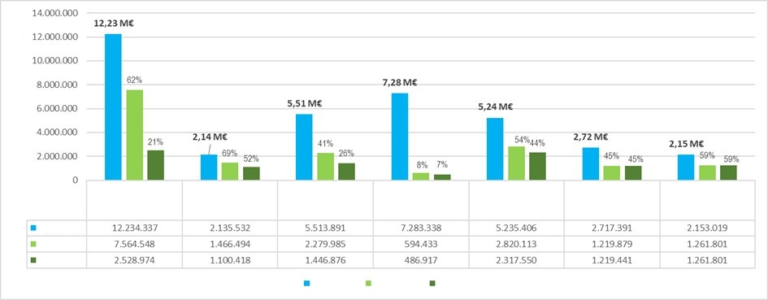
Approved
Paid
Pagado
Apropiado
Aprobado
1 Sustainable forest development and Governance

2 Planificación y desarrollo sectorial sostenible
3 Desarrollo agroambiental
4 Gobernanza ambiental con pueblos indígenas
5 Condiciones habilitantes
6 Operatividad
7 Mecanismo Financiero
Apropiado
EUROS
Figure 30. Budget Execution by Pillars
Pillar 1 Governance and sustainable forest development, appropriated 62% of its budget, mainly with the Amazon Forest Incentive, the second stage or phase of the Escuela de Selva, the strengthening of environmental governance of regional environmental authorities and the implementation of the 6 Forest and Biodiversity based Development Units [NDFyB].
Pillar 2 Planning and sustainable sectoral development appropriated 69% of the approved resources, including the signing of an agreement with the National Land Agency [ANT] to support the legal security of land in the areas of intervention of the Programme, with the CDA for the updated diagnosis of the traditional mining communities settled on the banks of the Guainía River, with the Amazonía Viva consortium for participatory land planning and participatory environmental zoning in the villages of the NDFyB Agua Bonita, and with 7 municipalities in Guaviare, Vaupés and Caquetá (San José del Guaviare, Retorno, Miraflores, Calamar, Taraira, Carurú and Cartagena del Chairá) for the formulation of their Municipal Development Plans 2024-2027, which were approved by their corresponding Municipal Councils. These plans included Programmes and actions to reduce deforestation and promote the bioeconomy, including nature tourism. In the same vein, support was provided for the development of the Departmental Development Plan of Guaviare.
Pillar 3 Agro-environmental Development appropriated 41% of the budget, especially through the agreement with the Agrarian Bank for the application of green credits, with the IFV Consortium for the provision of technical assistance services for food sovereignty to producers in the NDFyB and 6 departments (Caquetá, Putumayo, Guaviare, Amazonas, Guainía and Vaupés) for the provision of rural extension services, as well as with the municipalities of Calamar and San Vicente del Caguán.
Pillar 4 Environmental Governance with indigenous peoples is in the structuring of the projects prioritized in the framework of the fourth call of the PIVA, so its current appropriation is 8%. In the appropriate contracts, the development of the Prior Consultation of the Visión Amazonía Programme and the strengthening of governance and the exercise of self-government of the indigenous communities linked to the Association of Indigenous Councils of San Vicente del Caguán, ACISC, stand out.
Pillar 5 Enabling Conditions appropriated 54% of its budget, which includes the signing of the Agreement with IDEAM to monitor deforestation in the Programme's intervention areas.
The Financial Mechanism has appropriated 59% of the resources, in accordance with the provisions of the Programme's Operating Manual and the service provision contract between Minambiente and FPN.
The main contracts and agreements signed in 2024 were as follows:
Table 20. Main appropriate processes (€)
Implementing Entity | Subject Matter | Appropriated | Paid
CORPOAMAZONIA | IFA and control and surveillance | 2,191,623 | 744,098
CDA | IFA and control and surveillance | 1,720,012 | 81,636
CORMACARENA | IFA and control and surveillance | 1,323,721 | 32,463
BAC | Green Credits | 1,029,909 | 257,477
IDEAM | Forest monitoring | 807,687 | 240,275
UNIAMAZONIA | Escuela de Selva | 720,936 | 17,405
ANT | Legal security of land | 341,930 | 283,151
MPIO OF CALAMAR | Rural extension and development plan | 178,413 | 20,797
ACISC | Indigenous governance | 108,984 | 1,735
PUTUMAYO TECHNOLOGICAL INSTITUTE | Forest module | 107,110 | 0
GUAVIARE GOVERNMENT | Rural extension | 104,000 | 67,765

For its part, Patrimonio Natural signed contracts totalling €7,754,996, allocated to contracts for the pillars established in the procurement plans, UER personnel, operational activities and the financial mechanism costs.

The budget of €37,272,915 is planned to be executed 57% through implementing entities (such as regional autonomous corporations, territorial entities, public universities and research institutes, among other organizations). The remaining 43% is executed through the Patrimonio Natural Fund, which, in addition to covering operational activities, UER personnel and the financial mechanism costs of the Programme, also plays an important role as an implementing entity. Details of execution by implementing entities can be reviewed in Annex 5.

Budget Execution by Results
50,6% of the distribution of benefits is allocated to Result 1 Comprehensive Intervention in Forest Development Units, which achieved an appropriation of 60%, based on Pillar 1, 2 and 3 contracts and sub-agreements aimed mainly at sustainable forest management, nature tourism, support for the legal security of land, access to incentives, credits and other green financial instruments, rural extension, technical, social and business support and capacity building of local communities and organizations.
Table 21. Budget Execution by Results (€)
Results | Approved | Appropriated | Executed | Approp. | % Executed | Participation
Benefit Sharing | 35,084,752 | 15,945,286 | 6,327,152 | 45,4% | 18,0% | 94,1%
R1 Integrated Intervention in Forest Development Units | 17,763,372 | 10,658,340 | 2,655,267 | 60,0% | 14,9% | 50,6%
R2 Indigenous Environmental Governance | 7,423,838 | 734,933 | 542,372 | 9,9% | 7,3% | 21,2%
R3 Institutional Strengthening | 9,897,542 | 4,552,012 | 3,129,512 | 46,0% | 31,6% | 28,2%
Financial Mechanism | 2,188,163 | 1,261,801 | 1,137,567 | 57,7% | 52,0% | 5,9%
Total | 37,272,915 | 17,207,086 | 7,464,718 | 46,2% | 20,0% | 100,0%
Based on FPN Annual Financial Report
Result 2 Indigenous Environmental Governance participates with 21%, in accordance with the distribution of benefits of the Programme, and recorded a low appropriation and execution, due to the progress of the agreements with the Amazon Regional Roundtable, and the signature of the winning projects of the fourth call is expected in the second quarter of 2025. Result 3 Institutional Strengthening has 28% of the distribution of benefits and managed to appropriate 46% of its resources, which were oriented to support territorial entities (governors and municipalities) and national and regional environmental authorities to be strengthened in forest management and governance and in monitoring deforestation.

Financial Yields and Exchange Rate Differential
As of December 31, 2024, financial yields of COP 37,803 million have been obtained, estimated at €7,786,794; the exchange rate differential is COP 167 million.

Profit Distribution, Stock and Flow
Payments have been allocated 44% to local investments and 56% to the creation of favourable conditions and related policies, which is understandable considering that the Programme is currently in its preparation stage and at the beginning of its interventions.
Favourable Conditions and Related Policies
56%

Stock
14%
Flow
86%
Figure 31. Budget Execution by Pillars

Regarding the stock & flow distribution, 86% of local investment was allocated to actions aimed at reducing deforestation (flow) through Pillars 1 Forest Governance and 3 Agro-environmental, and 14% to activities that protect existing forests (stock), through Pillar 4 Indigenous.
PIVA Projects 18.099 EUR1%
IFA 877.697 EUR31%
Prior Consultation 395.998 EUR14%
Sectorial Issues 390.130 EUR14%
Forestry 347.231 EUR13%
IFV 269.004 EUR10%
Area 258.922 EUR9%
Others PIVA 89.799 EUR3%
Others PIVA 89.799 EUR3%
Figure 32. Distribution of Local Investment Executed
Payments for local investment financed activities associated mainly with the payment of the IFA, the prior consultation of the Visión Amazonía Programme, within the framework of the agreements with the MRA, and the development of the Forest Development Units.

Changes in the Implementation Context
The year 2024 has been characterized by public order difficulties. For the first time in the 7 years of implementation, the REM Programme has been forced to suspend activities in 4 of its NDFyB, namely Orotuyo, Nueva Ilusión, El Camuya and Ciudad Yarí in Caquetá since November 2023. Activities were also temporarily suspended in Calamar (NDFyB Los Puertos and Agua Bonita). The Ministry has been kept permanently informed through follow-up committees and other means, as well as KfW. In response to this situation, the Programme has proposed advancing in strengthening the beneficiaries of the NDFyBs through training courses and processes for acquiring equipment for sustainable forest use.
In view of the inauguration of the new departmental and municipal administrations on January 1, 2024, the Programme identified the opportunity to support the development of their respective municipal development plans, including topics such as the Land Use Management Schemes [EOT for its acronym in Spanish] and the NDFyB, while strengthening relationships with the mayors.
The Programme has been providing technical support to the Ministry of Environment’s Fund for Life and Biodiversity, particularly in conceptualizing the Conservar Paga Programme based on its experience with IFA. At the Minister’s request, a new financial incentive for productive restoration "RePro" has also been designed. In the coming semester, the Director and a technical team for the Fund will be hired, with the expectation that it will begin operations.

Challenges and Priorities for REM II
Taking into account that the peace negotiation process is dynamic, this has meant that the timely implementation of the REM COLOMBIA II Programme in the NDFyB areas is subject to security conditions, particularly in Caquetá. This requires ongoing monitoring of the public order situation, given the potential risks for both beneficiaries and the Programme's field personnel. It is evident that the Programme will operate amidst heightened conflict in the region, and in order to guarantee the long-term viability of the REM Programme, it will be necessary to exercise extreme caution regarding personnel and maintain strict neutrality towards illegal groups.
Within the framework of the Integrated Plan for Deforestation Control, Minambiente, through the Fund for Life and the Environmental National Fund [FONAM for its acronym in Spanish], channelled resources to the entities of the National Environmental System [SINA for its acronym in Spanish] for interventions in each of the 22 NDFyB areas in the Amazon, complemented by the REM Colombia Visión Amazonía Programme and the FAO-GCF Visión Amazonía. Although the REM Colombia II Programme continues to offer advances and methodologies in areas such as forest certification, each implementing entity has begun investments in the field independently and not necessarily with the same methodologies. Therefore, it is important to coordinate with the various interventions being carried out by the Forestry Directorate of the Ministry of Environment to ensure methodological consistency, a task in which the REM Colombia II Programme could potentially provide support.
In response to a legal protection action (tutela) filed by the Indigenous Council of Pirá Piraná in Vaupés due to a carbon project of Corporación Masbosque, the Constitutional Court in its ruling T-248-24 orders the Minambiente to regulate the carbon credit market in Colombia. The Programme will be supporting this regulation as long as the government requests it.
Although the process of the Prior Consultation of the Visión Amazonía Programme under the responsibility of the Ministry of the Environment has not yet been completed, the result may have implications for the implementation of the REM II Programme and especially for future cooperation projects.
Minambiente was unable to operationalize the Conservar Paga Programme in 2024, which generated uncertainty and discontent among the beneficiaries. The commitment is to assume the payments starting in 2025, including the beneficiaries of the REM Programme. To avoid any reputational risk for the REM Programme, it is proposed that Minambiente promptly communicates any eventuality in the process in order to keep the target population informed.

Annexes

Annex 1 Definitions of Financial Concepts
According to the Programme's financial reports, the main concepts used in this report are defined as follows:
Sub-agreement: Legal instrument signed between Fondo Patrimonio Natural and a private implementing entity for the technical and financial execution of the activities contemplated in the Annual Work Plan. In this modality, the implementing entity directly executes the resources transferred to it by FPN.
Agreement: Legal instrument signed between the Natural Heritage Fund and an implementing entity of the Public or Private Order for the technical execution of the activities contemplated in the Annual Work Plan. In this modality the resources foreseen in the Agreement are executed directly by FPN.
Appropriated: Refers to the Resguardo of a specific volume of resources as a result of the signing of various types of legal agreements, such as sub-agreements, partnership agreements, framework agreements, co-execution agreements, and direct contracts by FPN, which entails a reduction in budget availability.
Transferred: Refers to the amounts disbursed to implementing entities under the framework of the sub-agreements, to facilitate the payments established in the respective Procurement Plan.
Committed: Refers to the volume of contracts or commitments that have been signed with suppliers of goods and services, as follows: i) Contracts signed by the Implementing Entities for the execution of the Sub-agreements; ii) Contracts signed by FPN for the execution of cooperation agreements with other implementing institutions; and iii) Contracts signed directly by FPN for the execution of the Programme’s Operational component (for example, contractors and UER staff, main advisory firm, Financial Mechanism services contract, etc.).
Executed/Paid: Refers to the amounts that have been effectively paid by the Implementing Entities and FPN to the Programme’s suppliers of goods and services, in compliance with the contractual clauses, once the goods and services have been satisfactorily received, the invoice or equivalent document has been submitted, and the corresponding contract supervisor’s approval has been obtained.

The final table of selected projects is as follows:
DEPARTMENT | PROJECT | IMPLEMENTING ENTITY | MODALITY | BUDGET
GUAVIARE | Strengthening of Amazonian indigenous knowledge systems for planning, conservation, management, sustainable use and administration of the territory, through intercultural strategies for forest management and use, biocultural monitoring systems and strategic guidelines on REDD+ for the Nukak Resguardo. | NUKAK MAKU INDIGENOUS RESGUARDO | GENERAL | 1,280,000,000
AMAZON | Murui Women, Guardians of Knowledge: Resilience and Resistance through Gatherings Articulated with Traditional Practices for the Visibility and Survival of the Murui People of the Government Council of the Association of Cabildos and Traditional Authorities of the Murui People’s Indigenous Major Council – CIMPUM. | Association of Councils (Cabildos) and Authorities of the Major Indigenous Council of the Murui People - CIMPUM | WOMAN | 1,100,000,000
GUAINIA | Strengthening of organizational structures for the Governance and Guarantee of Food Security for the Indigenous Peoples of the Department of Guainía, through support to family conucos of 13 indigenous organizations. | Association of the Indigenous Regional Council of Guainía ASOCRIGUA 1 | WOMAN | 1,100,000,000
GUAINIA | Strengthening of the Governance of the traditional authority, ancestral knowledge, arts and customs in the Remanso Chorro Bocón Resguardo. | REMANSO CHORROBOCON INDIGENOUS RESGUARDO | GENERAL | 1,000,000,000
AMAZON | Strengthening food sovereignty and self-governance through the establishment of Associative Social and Solidarity Economy Enterprise led by indigenous women for the sustainable management of Food Programmes in the territory of AZICATCH, ANM of La Chorrera Amazonas. | Zonal Indigenous Association of Cabildos and Traditional Authorities of La Chorrera - AZICATCH | WOMAN | 1,000,000,000
VAUPES | The care of women's health and body for territorial Good Living. | United Indigenous Territory of the Isana and Surubí Rivers -TIURIS-. | WOMAN | 990,781,000
VAUPES | Strengthening the integral system of administration and territorial governance of the Jaguares de Yurupari in the Indigenous Territory of the Pirá Paraná River. | Association of Indigenous Captains and Traditional Authorities of the Pirá Paraná River - ACAIPI | GENERAL | 990,000,000
GUAVIARE | Implementation of Traditional Knowledge Systems through the Establishment of Traditional Chagras*, Rehabilitation of Environmentally Important Areas, and Institutional Strengthening of Women, Children, and Families of the CRIGUA II Association  (*Small area of cultivated land. T.N.) | ASSOCIATION OF INDIGENOUS AUTHORITIES OF THE GUAVIARE (CRIGUA II) | WOMAN | 940,000,000
CAQUETA | Sustainable strengthening of their own economies through the leadership of Korebaju indigenous women affiliated to the CRIOMC Association. | ASSOCIATION OF TRADITIONAL AUTHORITIES OF THE REGIONAL INDIGENOUS COUNCIL OF ORTEGUAZA MEDIO CAQUETÁ - CRIOMC | WOMAN | 900,000,000
CAQUETA | Strengthening of traditional systems of sustainable production and self-governance through the implementation of traditional chagras and the updating of planning instruments to improve territorial governance in the Inga indigenous communities of the department of Caquetá. | ASSOCIATION OF INDIGENOUS COUNCILS TANDACHIRIDU INGANOKUNA | WOMAN | 900,000,000
GUAVIARE | TERRITORIAL APPROPRIATION AND GOVERNANCE OF THE JIW PEOPLE | ASSOCIATION OF AUTHORITIES OF THE JIW GUAVIARE INDIGENOUS PEOPLE - ASOAPIJG | GENERAL | 900,000,000
PUTUMAYO | Indigenous life plan as an alternative to strengthen the self-governance systems of eight (8) Inga communities in the municipality of Villagarzón, department of Putumayo. | The Association of Indigenous Councils of the Municipality of Villagarzón Putumayo - ACIMVIP | GENERAL | 880,000,000
VAUPES | CRIVA: The union of thought of the indigenous peoples of Vaupés | Association of Traditional Indigenous Authorities of Lower Vaupes (ASATRIBVA) | GENERAL | 844,000,000
PUTUMAYO | IMPLEMENTATION OF THE ENVIRONMENTAL MANAGEMENT PLAN OF THE KICHWA PEOPLE, MUNICIPALITY OF LEGUIZAMO, DEPARTMENT OF PUTUMAYO. | ASSOCIATION OF COUNCILS OF THE KICHWA PEOPLE OF PUTUMAYO | GENERAL | 804,000,000
VAUPES | Life Plan for the Survival of the Indigenous Peoples of the Association of Indigenous Traditional Authorities of the Central Zone of Mitú- AATIZCEM | Association of Traditional Indigenous Authorities of the Central Zone of Mitú- AATIZCEM | GENERAL | 800,000,000
CAUCA | Revitalization of ancestral knowledge and practices of the Inga people for the harmonization of Territory and Food Sovereignty in the Nukanchipa Atunkunapa Alpa Association. | Nukanchipa Association Atunkunapa Alpa | GENERAL | 800,000,000
GUAINIA | Women Caretakers of the ancestral territory of the Curripaco people for the defence of life and the rights of future generations. | Association of Traditional Indigenous Authorities Captains of the Curripaco Communities of the Middle Guainía River JAJLAMI | WOMAN | 770,000,000
GUAINIA | Improvement and use of natural resources through the installation of mobile eco-efficient stoves and forest seedlings for the CAÑO RAYA community of the Atabapo and Inírida river Resguardo. | ASSOCIATION OF TRADITIONAL INDIGENOUS AUTHORITIES - CAPTAINS OF THE ATABAPO AND INIRIDA RESGUARDO - AIRAI | GENERAL | 750,000,000
GUAVIARE | STRENGTHENING THE GOVERNANCE AND ATLAS OF THE NATIVE PEOPLE OF INDIGENOUS TRADITIONAL AUTHORITIES | ASSOCIATION OF TRADITIONAL INDIGENOUS AUTHORITIES ASOPAMURIMAJSA | GENERAL | 750,000,000
VICHADA | WEAVING WISDOM AND CULTURAL IDENTITY FOR THE WOMEN AND THEIR FAMILIES OF THE LAGUNA ANGUILLA LA MACARENA INDIGENOUS RESERVATIOIN IN THE MATAVEN FOREST. | ACATI-RLAM | WOMAN | 690,000,000
VAUPES | "Food security of indigenous communities of lower Vaupés: the chagra, axis of culture and protection of mother nature". | Association of Traditional Indigenous Authorities of Yaigoje Apaporis-Vaupés-ACIYAVA | WOMAN | 670,000,000
VICHADA | Strengthening of the Piapoco people's own knowledge systems related to food autonomy and environmental governance in the Cali Barranquilla Resguardo. | INDIGENOUS RESGUARDO CALI BARRANQUILLA | WOMAN | 650,000,000
PUTUMAYO | In the forest we learn, conserve, utilize and make sustainable use of the forests of the Calarcá indigenous Resguardo (Sacha runa Yachay, waqaychay takyasqa tanqay), in the Calarcá Resguardo. Second phase | Calarcá Indigenous Resguardo | GENERAL | 650,000,000
CAQUETA | Korebaju woman, caregiver and generator of life for the good living of the Bajuromi family and community. | ASIMC (The Association of Indigenous. Traditional Indigenous Authorities of the Municipality of Solano). | WOMAN | 640,000,000
GUAINIA | Integrated Environmental Governance [GAI for its acronym in Spanish] from indigenous knowledge systems for Climate Change Mitigation and Adaptation in the Resguardo "CMARI Territorio de Vida y Progreso" (Territory of Life and Progress). | Cuenca Media y Alta Rio Inírida-CMARI  Upper Inírida River-CMARI Indigenous Resguardo | GENERAL | 600,000,000
GUAVIARE | Ecological recovery through the sustainable production of Amazonian fruits in the indigenous Resguardo of El Itilla, Department of Guaviare. | EL ITILLA indigenous Resguardo | GENERAL | 600,000,000
PUTUMAYO | “Uai monoka, ñue uño, yofue, kaienu+" The word heals, cares for, teaches, and orders the territory. Weaving baskets for the cultural revitalization, transmission of knowledge, livelihoods and governance of the Murui Muina (Uitoto) Nonuetoma Imak+ community in the municipality of Leguízamo, Putumayo. | Murui Muina (Uitoto) Nonuetoma Imak+ Community | WOMAN | 600,000,000
PUTUMAYO | "Strengthening the indigenous women of the communities: Quillasinga Inti Wasi Council (cabildo), Piedra Sagrada Resguardo, la gran familia los Pastos, Pastos Huellas Ancestrales Council, Pastos Orito Council, Siona Buena vista Resguardo, Siona Vegas de Santa Ana Resguardo and Misak el Afilador Council, of the department of Putumayo, with a focus on political, ancestral and environmental leadership as caretakers of the Amazon territories, and endowment of their ancestral costume preserving their cultural identity". | Piedra Sagrada,La Gran Familia Los Pastos Resguardo | WOMAN | 580,000,000
AMAZON | Opening meaningful contexts of knowledge transmission processes to strengthen the autonomy and cultural identity of the indigenous peoples of the Mirití-Paraná Resguardo, Amazonas. CITMA | INDIGENOUS COUNCIL OF THE MIRITÍ PARANÁ AMAZONAS TERRITORY - CITMA | GENERAL | 560,000,000
PUTUMAYO | Ancestral strengthening through the establishment of chagras with an agroforest design in the Inga indigenous Resguardo of Puerto Limón municipality of Mocoa - Inga Wasipanga indigenous Resguardo municipality of Puerto Guzmán - department of Putumayo. | Puerto Limón - Wasipanga | WOMAN | 550,000,000
VAUPES | Protecting, preserving and strengthening the food sovereignty of our territory. | Asociación Zonal Indígena del Rio Papunahua-AZIRPA (Papunahua River Indigenous Zonal Association) | WOMAN | 500,000,000
GUAVIARE | Generation of a positive impact on the economic and cultural environment of women, youth and families of La Fuga Indigenous Resguardo, through the creation of the Community Ethnotourism offer. | La Fuga Indigenous Resguardo | WOMAN | 487,000,000
GUAINIA | Strengthening of self-government by updating the Life Plan of the Curripaco Indigenous Resguardo and others in Tierra Alta. | Curripaco and others of Tierra Alta Indigenous Resguardos. | WOMAN | 469,000,000
AMAZON | Strengthening of the intercultural leadership of the ITEGWA women's process of the PANI indigenous territory. | Indigenous Council of the PANI Territory | WOMAN | 415,570,000
GUAINIA | Our Territory "Wajipaite" as an articulating axis of the Coayare El Coco Resguardo | ASSOCIATION OF TRADITIONAL INDIGENOUS AUTHORITIES OF THE COAYARE EL COCO RESGUARDO  ASOCOAYARE | GENERAL | 400,000,000
VAUPES | Update of the Life Plan of the ASATIQ Zone | Association of Indigenous Traditional Authorities of Querari ASATIQ | GENERAL | 400,000,000
PUTUMAYO | Recovery of Native Plants that Contribute to Soil and Water Care and Possess Medicinal Properties, Supported by the Knowledge of Nasa Women from the La Aguaditas Indigenous Reserve, Municipality of Puerto Guzmán, Putumayo | Páez la Aguadita Indigenous Resguardo | WOMAN | 360,000,000
GUAVIARE | "Roots of El Refugio: Ethnic Tourism Led by Women." | El Refugio Indigenous Resguardo | WOMAN | 360,000,000
GUAVIARE | Seeds of life: Women of the forest restoring their village's water governance | Indigenous reserve of the Tucana de la Yuquera indigenous community | WOMAN | 290,000,000
CAQUETA | Murui women as a fundamental pillar of the people's thinking and their role in the transmission of knowledge as a contribution to cultural strengthening and territorial and environmental governance. | Coropoya Indigenous Resguardo | WOMAN | 269,655,000
VAUPES | Waimaja" ancestral house to associate women who preserve their ancestral knowledge and handicraft skills to generate new family income. | San Francisco del Tique | WOMAN | 226,449,400
AMAZON | Implementation of income-generating economic initiatives that are culturally, environmentally and productively sustainable in the communities belonging to the AZCAITA Association, in the municipality of Leticia, department of Amazonas. | Zonal Association of the Council of Indigenous Authorities of Ancestral Tradition (AZCAITA) | GENERAL

Annex 3: OPIAC Proposal Presented at the MRA, to Redefine the Pillars of the Visión Amazonía Programme to Incorporate Indigenous Peoples.
Pillar 1: Governance and Sustainable Forest Development
Objective: To guarantee territorial governance and governability in the Colombian Amazon based on the knowledge systems of the Amazonian Indigenous Peoples, their institutions, governments, authorities and traditional instruments, establishing the necessary mechanisms for coordination and articulation with the national government in the construction and implementation of strategies, policies, plans, programmes and projects.
Pillar 2: Sustainable Sectoral Planning and Development
Objective: To ensure the active and effective participation of indigenous authorities and governments, based on their Knowledge Systems and ancestral wisdom, in decision-making processes at the local, regional and national levels for sustainable sectoral planning. This will de achieves through the construction, updating and coordination of their own planning instruments (Life Plans and their equivalents) with the planning, land-use management and public policy instruments of State institutions.
Pillar 3: Agro-environmental Development
Objective: To strengthen the indigenous economy through the production and supply of goods and services derived from their territories and nature, which are profitable, sustainable and environmentally responsible. This will be based on knowledge systems focused on life care, forest management, conservation, and preservation of Amazonian biodiversity. These processes will be carried out in harmony with complementary techniques and technologies, respecting and protecting life, culture, ancestral knowledge and indigenous governance systems, ensuring direct administration by the indigenous peoples.
Pillar 5: Enabling Conditions
Objective: To guarantee the necessary conditions for indigenous authorities and governments to care for their territories in coordination with the national government, through the provision of technical, technological and financial resources, as well as training and capacity building of human talent.
- For the implementation of the PVA, it will be ensured that no double accounting or restrictions regarding the actions and initiatives of nature-based solutions developed by Indigenous Peoples PPII] in their territories.
- NDFs, noting that they should not be applied in Indigenous Territories.
- The peasant forestry concessions and other non-indigenous environmental protection figures shall not apply in the case of Indigenous territories and territorialities in accordance with national and international regulations in force.

Annex 4: Some links to news about the Programme published in the media.
- ESCUELA DE SELVA
https://www.semana.com/medio-ambiente/articulo/escuela-de-selva-un-aula-virtual-para-conocer-las-bondades-del-bosque/55856/
- Community Council for Rural Development in Cartagena del Chairá and signing of a framework agreement with the municipality.
https://web.facebook.com/story.php?story_fbid=1042705333564799&id=100034760276297&mibextid=WC7FNe
- MAYORS COMMITTED TO conservation
https://www.vanguardia.com/mundo/ola-verde/siete-alcaldias-comprometidas-con-el-cuidado-de-la-amazonia-en-colombia-AD8621839
- FSC CERTIFIED WOOD
https://www.facebook.com/story.php?story_fbid=241458542372814&id=100095260099433&mibextid=Nif5oz
- FOURTH INDIGENOUS CALL
https://www.elespectador.com/ambiente/amazonas/minambiente-anuncio-28000-millones-para-proyectos-de-pueblos-indigenas-de-la-amazonia/?outputType=amp
- INTERZUM - FEDEMADERAS -VISION AMAZONIA - ARTS AND CRAFTS SCHOOL
https://www.areacucuta.com/fedemaderas-se-une-a-la-feria-interzum-bogota-para-aportar-en-el-futuro-de-la-carpinteria-arquitectonica-y-el-mobiliario/
- GLOBAL BIG DAY
https://www.rcnradio.com/colombia/colombia-fue-reconocido-como-el-pais-con-mayor-diversidad-de-aves-segun-big-day-2024
- GUAVIARE FOREST TABLE
https://marandua.com.co/guaviare-mesa-forestal-se-realizara-este-viernes-en-san-jose-del-guaviare/
- DEFORESTATION ALERTS IN GUAVIARE
https://guaviareestereo.com/podcast-alertas-por-deforestacion-en-el-primer-trimestre-del-2024-16-06-2024/

Annex 5 Budget Execution by Pillars and Components (€)
Pillars | Approved | Appropriated | Executed | %  Appro. | % Executed
1 Governance and Sustainable Forest Development | 12,234,337 | 7,564,548 | 1,600,675 | 62% | 13%
1.1 Planning and sustainable use of forest resources | 3,229,271 | 892,683 | 141,939 | 28% | 4%
1.2 Strengthening of forest governance of environmental authorities | 1,675,703 | 429,122 | 181,199 | 26% | 11%
1.3 Promoting Participation in Forest Management | 7,329,363 | 6,242,744 | 1,277,537 | 85% | 17%
2 Sustainable Sectoral Planning and Development | 2,135,532 | 1,466,494 | 781,225 | 69% | 37%
2.1 Land use planning | 935,972 | 571,469 | 365,891 | 61% | 39%
2.2 Support for territorial entities committed to controlling deforestation | 477,116 | 476,058 | 112,980 | 100% | 24%
2.3 Development of strategic and capacity-building activities | 722,444 | 418,968 | 302,354 | 58% | 42%
3 Agro-environmental Development | 5,513,891 | 2,279,985 | 674,758 | 41% | 12%
3.1 Implementation of agro-environmental projects with conservation agreements | 2,409,904 | 319,125 | 146,833 | 13% | 6%
3.2 Promotion of the rural extension service | 1,282,870 | 586,952 | 258,922 | 46% | 20%
3.3 Promotion and implementation of green financial instruments | 1,821,118 | 1,373,908 | 269,004 | 75% | 15%
4 Environmental Governance with Indigenous Peoples | 7,283,338 | 594,433 | 421,564 | 8% | 6%
4.1 Implementation of indigenous projects through calls for proposals | 6,357,169 | 123,458 | 18,099 | 2% | 0%
4.2 Capacity building of indigenous organizations | 926,169 | 470,975 | 403,465 | 51% | 44%
5 Qualifying Conditions | 5,235,406 | 2,820,113 | 2,160,321 | 54% | 41%
5.1 Regional and local level forest and carbon monitoring | 984,834 | 873,292 | 305,880 | 89% | 31%
5.2 UER Personnel | 3,720,146 | 1,772,193 | 1,687,380 | 48% | 45%
5.3 Implementation of Communications Strategy | 530,426 | 174,627 | 167,061 | 33% | 31%
6 Operations | 2,717,391 | 1,219,879 | 704,353 | 45% | 26%
6.1 Audits and evaluations | 262,181 | 7,415 | 7,415 | 3% | 3%
6.2 International Consultancy | 707,742 | 707,742 | 196,891 | 100% | 28%
6.3 Travel and event logistics costs | 309,596 | 171,433 | 171,315 | 55% | 55%
6.4 Equipment, banking fees and contingencies | 1,437,873 | 333,289 | 328,731 | 23% | 23%
7 Financial Mechanism | 2,153,019 | 1,261,801 | 1,137,567 | 59% | 53%
7.1 Cost of Financial Mechanism | 2,153,019 | 1,261,801 | 1,137,567 | 59% | 53%
Total | 37,272,915 | 17,207,254 | 7,480,462 | 46% | 20%

Annex 5 Budget Execution by Implementing Entities (€)
IMPLEMENTER | SUBJECT | APPROVED | APPROPRIATE | EXECUTED | %  APROP | %  EJEC
CORPOAMAZONIA | Forest participation | 2,047,436 | 2,047,436 | 683,775 | 100% | 33%
CORPOAMAZONIA | Control and surveillance | 144,187 | 144,187 | 60,323 | 100% | 42%
CDA | Forest participation | 1,452,236 | 1,452,236 | 40,475 | 100% | 3%
CDA | Sector performance | 164,785 | 164,785 | 0 | 100% | 0%
CDA | Control and surveillance | 102,991 | 102,991 | 41,161 | 100% | 40%
CORMACARENA | Forest participation | 1,220,730 | 1,220,730 | 13,863 | 100% | 1%
CORMACARENA | Control and surveillance | 102,991 | 102,991 | 18,600 | 100% | 18%
BAC | Green Instruments | 1,029,909 | 1,029,909 | 257,477 | 100% | 25%
IDEAM | SMByC | 807,687 | 807,687 | 240,275 | 100% | 30%
UNIAMAZONIA | Forest participation | 720,936 | 720,936 | 17,405 | 100% | 2%
ANT | Land use planning | 341,930 | 341,930 | 283,151 | 100% | 83%
CALAMAR MUNICIPALITY | Sector performance | 96,020 | 96,020 | 15,009 | 100% | 16%
CALAMAR MUNICIPALITY | Agricultural extension | 82,393 | 82,393 | 5,788 | 100% | 7%
CALAMAR MUNICIPALITY | Capacity building | 57,387 | 57,387 | 57,387 | 100% | 100%
GUAVIARE GOVT. | Agricultural extension | 126,710 | 126,710 | 83,831 | 100% | 66%
GUAVIARE GOVT. | Sector performance | 15,986 | 15,986 | 0 | 100% | 0%
ACISC | PIVA | 108,984 | 108,984 | 1,735 | 100% | 2%
NATUPAZ | Forest participation | 102,991 | 102,991 | 52,010 | 100% | 50%
CARURÚ MUNICIPALITY | Capacity building | 99,275 | 99,275 | 29,839 | 100% | 30%
ASOJ. CALAMAR | Forest participation | 88,325 | 88,325 | 75,073 | 100% | 85%
SAN VICENTE DEL CAGUAN MUNICIPALITY | Forest participation | 41,196 | 41,196 | 0 | 100% | 0%
SAN VICENTE DEL CAGUAN MUNICIPALITY | Agricultural extension | 28,014 | 28,014 | 0 | 100% | 0%
ASOJ. C.CHAIRA | Forest participation | 64,511 | 64,511 | 64,511 | 100% | 100%
SOLANO MUNICIPALITY | Forest participation | 41,196 | 41,196 | 0 | 100% | 0%
ASOPEREGRINOS | AgrO-environmental projects | 26,874 | 26,874 | 7,918 | 100% | 29%
VAUPES GOVT. | Agricultural extension | 24,382 | 24,382 | 24,382 | 100% | 100%
GUAINIA GOVT. | Agricultural extension | 24,100 | 24,100 | 5,356 | 100% | 22%
EL RETORNO MUNICIP. | Capacity building | 22,404 | 22,404 | 22,404 | 100% | 100%
PUTUMAYO GOVT. | Agricultural extension | 22,040 | 22,040 | 18,621 | 100% | 84%
CAQUETA GOVT. | Agricultural extension | 21,799 | 21,799 | 21,799 | 100% | 100%
CARTAGENA DEL CHAIRA MUNICIPALITY | Sector performance | 21,253 | 21,253 | 15,613 | 100% | 73%
OF SAN JOSE DEL GUAVIARE MUNICIPALITY | Capacity building | 20,528 | 20,528 | 20,528 | 100% | 100%
MIRAFLORES MUNICIPALITY | Capacity building | 19,307 | 19,307 | 19,307 | 100% | 100%
IN PROCESS |  | 11,758,999 | 0 | 0 | 0% | 0%
SUBTOTAL E.I. |  | 21,050,490 | 9,291,491 | 2,197,615 | 100% | 24%
FONDO PATRIMONIO NATURAL | Implementer and Financial Mechanism | 16,061,826 | 7,755,164 | 5,249,545 | 48% | 33%
TOTAL REM II |  | 37,272,915 | 17,207,254 | 7,480,462 | 46% | 20%

REM Colombia II Visión Amazonía Programme

Financial Mechanism

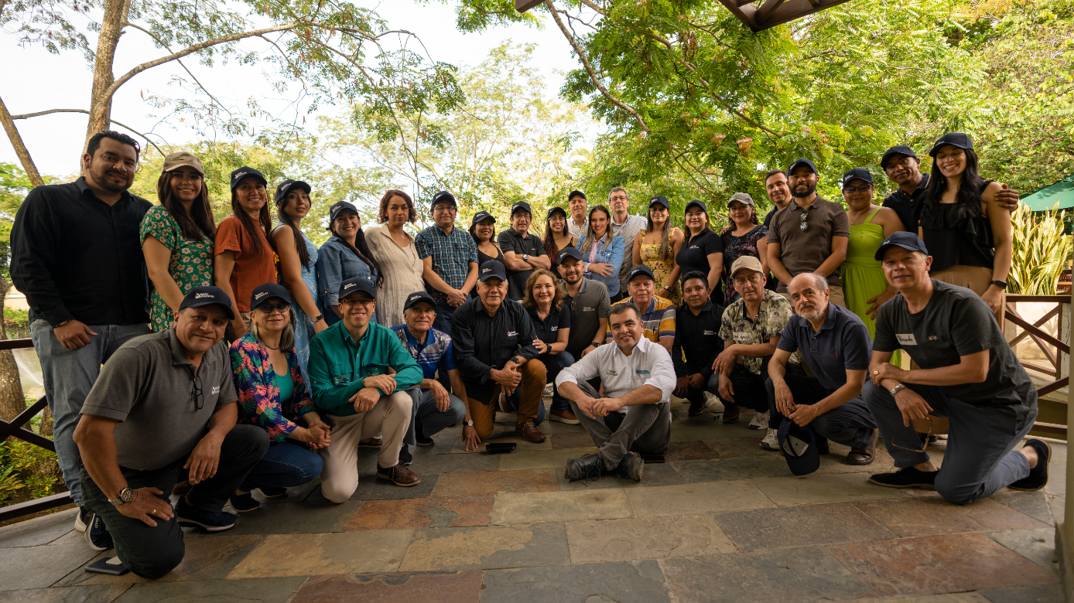
The REDD Early Movers Colombia II Visión Amazonía Programme (REM COLOMBIA II) is co-financed by the Kingdom of Norway, the United Kingdom of Great Britain and Northern Ireland and the Federal Republic of Germany, through KfW
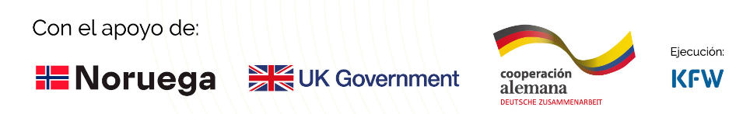
For more information see: http://visionamazonia.minambiente.gov.co
  - ² National Environmental Education Award 'Augusto Maya Ángel' — December 26, 2022.

- https://www.minambiente.gov.co/wp-content/uploads/2025/03/Plan-Integral-Contencion-Deforestacion-2023-2026.pdf

